 **Santa Clara Adult Education**

**Adult High School Diploma Program**

**ENGLISH 4-B**

**READINGS**

*RETURN TO TEACHER*

*WHEN YOU ARE FINISHED*

## **“Three Ways to Persuade” by *John Edlund***

## Over 2,000 years ago the Greek philosopher Aristotle argued that there were three basic ways to persuade an audience that you were right: *ethos, logos,* and *pathos*.

***Ethos*: The Writer’s Character or Image**

The Greek word *ethos* is related to our word *ethics* or *ethical*, but a more accurate modern translation might be image. Aristotle uses *ethos* to refer to the speaker’s character as it appears to the audience. Aristotle says that if we believe that a speaker has good sense, good moral character, and goodwill, we are inclined to believe what that speaker says to us. Today we might add that a speaker should also appear to have the appropriate expertise or authority to speak knowledgeably about the subject matter. *Ethos* is an important factor in advertising, both for commercial products and in politics. For example, when an actor in a pain reliever commercial puts on a doctor’s white coat, the advertisers are hoping that wearing this coat will give the actor the authority to talk persuasively about medicines. Of course, in this case the actor’s *ethos* is a deceptive illusion.

In our society sports heroes, popular actors and actresses, and rock stars are often seen as authorities on matters completely unrelated to their talents. This is an instance of the power of image. Can you think of some examples?

A writer’s *ethos* is created largely by word choice and style. Student writers often have a problem with *ethos* because they are asked to write research papers, reports, and other types of texts as if they have authority to speak persuasively, when in fact they are newcomers to the subject matter and the discourse community. Sometimes students try to create an academic image for themselves by using a thesaurus to find difficult and unusual words to sprinkle throughout their texts. Unfortunately, this sort of effort usually fails, because it is difficult to use a word correctly that you have not heard or read in context many times.

Sometimes a writer or speaker will use what is called an *ad hominem* argument, an argument against the man. In this strategy, you attack the character or personality of the speaker instead of attacking the substance of his or her position. This kind of argument is usually considered to be a logical fallacy, but it can be very effective, and is quite common in politics.

***Questions for Discussion:***

1. What kind of image do you want to project to your audience?
2. What can you do to help project this image?
3. What words or ideas do you want to avoid in order not to harm your image?
4. What effect do misspelled words and grammatical errors have on your image?

***Logos*: Logical Arguments**

In our society, logic and rationality are highly valued and this type of persuasive strategy is usually privileged over appeals to the character of the speaker or to the emotions of the audience. However, formal logic and scientific reasoning are usually not appropriate for general audiences, so we must rely on a more *rhetorical* type of reasoning.

For Aristotle, formal arguments are based on what he calls *syllogisms*. This is reasoning that takes the form:

*All men are mortal.*

*Socrates is a man.*

*Therefore, Socrates is mortal.*

However, Aristotle notes that in ordinary speaking and writing we often use what Aristotle calls a rhetorical syllogism or an *enthymeme*. This is an argument in which some of the premises remain unstated or are simply assumed. For example, no one in ordinary life would think that Socrates could be immortal. We would simply *assume* that Socrates could be killed or that he would die of natural causes after a normal lifespan. Not all assumptions are as trivial as this one, however.

For example, when Bubonic Plague swept through Europe and parts of Asia in the 14th century, killing as much as three quarters of the population in less than 20 years, it was not known how the disease was spread. At one point, people thought that the plague was spread by cats. If you *assume* that cats spread the disease, the obvious solution to the problem is to eliminate the cats, and so people began killing cats on sight. However, we now know that the plague is spread by fleas which live on rats. Because cats kill rats, killing off the cat population led to an increase in the rat population, a corresponding increase in plague carrying fleas, and thus an increase in cases of plague in humans. Killing off the cats was a logical solution to the problem of plague, but it was based on a faulty assumption.

Rhetorical arguments are often based on probabilities rather than certain truth. The people of medieval Europe really had no way to determine what the real cause of the plague was, but they felt that they had to do something about it, and the cat hypothesis seemed probable to them. Unfortunately, this is true of many of the problems we face even todaywe can not know with absolute certainty what the real solution is, yet we must act anyway.

Persuasion, to a large extent, involves convincing people to accept our assumptions as probably true. Similarly, exposing questionable assumptions in someone else’s argument is an effective means for preparing the audience to accept your own contrary position.

***Questions for Discussion***:

1. Imagine some arguments that start from faulty assumptions, such as “If pigs could fly,” or “If money grew on trees.” What would be some of the logical consequences?
2. Do you think that logical arguments are a better support for a position than arguments that are based on authority or character? In other words, would you support a policy just because a celebrity or an important expert supported it?
3. Can you think of a time when you used a logical argument to persuade someone of something? What was it?

***Pathos*: The Emotions of the Audience**

Most of us think that we make our decisions based on rational thought. However, Aristotle points out emotions such as anger, pity and fear, and their opposites, powerfully influence our rational judgments. Due to this fact, much of our political discourse and much of the advertising we experience is directed toward moving our emotions.

Anger is a very powerful motivating force. Aristotle points out that if we want to make an audience angry we need to know three things: 1) the state of mind of angry people, 2) who the people are that this audience usually gets angry at, and 3) on what grounds this audience gets angry at those people. The recent breakup of Yugoslavia into separate countries provides many examples of the power of this kind of rhetoric. Yugoslavia was created after the Second World War out of several smaller states, including Croatia, Serbia, Bosnia-Herzegovena, and Slovenia. Within each state there were ethnic and religious minorities with long histories of conflict. While Yugoslavia was under the control of the Soviet Union, these conflicts were kept in check by military force. With the collapse of the Soviet Union, new political structures were necessary, and political opportunities arose for the ambitious. The leaders of various factions, understanding Aristotle’s three points very well, began to mobilize their followers to war by reminding them of their historical grievances against other groups. Serbian leaders published photographs of atrocities allegedly committed by Croatians during WWII, reviving a conflict from 50 years earlier. Individuals were inspired through this angry rhetoric to attack, rape, and kill neighbors that had lived near them all their lives, simply because of their ethnicity or religion.

Many political decisions have an emotional motivation. For example, when a gunman with an assault rifle shot up a schoolyard full of children, people were suddenly interested in banning such weapons. In this case several emotions are involved, but perhaps the strongest one is pity for the small children and their families. The logical arguments for banning or not banning assault rifles had not changed at all, but people were emotionally engaged with the issue after this event and wanted to *do* something.

Many advertisements for consumer goods aim at making us insecure about our attractiveness or social acceptability, and then offer a remedy for this feeling in the form of a product. This is a common strategy for selling mouthwash, toothpaste, chewing gum, clothing, and even automobiles.

Appeals to the emotions and passions are a very effective rhetorical technique, and very common in our society. You may find it necessary to use them yourself.

***Questions for Discussion:***

1. Can you think of an advertisement for a product or a political campaign that uses your emotions to persuade you to believe something? Describe it, and analyze how it works.
2. Do you think it is unfair or deceptive to try to use emotions to persuade people?
3. Have you ever made a decision based on your feelings that you regretted later?

**A Change of Heart about Animals**

*They are more like us than we imagined, scientists are finding.*- ***Jeremy Rifkin*** *- 9/ 01/ 2003*

1. Though much of big science has centered on breakthroughs in biotechnology, nanotechnology and more esoteric questions like the age of our universe, a quieter story has been unfolding behind the scenes in laboratories around the world -- one whose effect on human perception and our understanding of life is likely to be profound.
2. What these researchers are finding is that many of our fellow creatures are more like us than we had ever imagined. They feel pain, suffer and experience stress, affection, excitement and even love -- and these findings are changing how we view animals.
3. Strangely enough, some of the research sponsors are fast food purveyors, such as McDonald's, Burger King and KFC. Pressured by animal rights activists and by growing public support for the humane treatment of animals, these companies have financed research into, among other things, the emotional, mental and behavioral states of our fellow creatures.
4. Studies on pigs' social behavior funded by McDonald's at Purdue University, for example, have found that they crave affection and are easily depressed if isolated or denied playtime with each other. The lack of mental and physical stimuli can result in deterioration of health.
5. The European Union has taken such studies to heart and outlawed the use of isolating pig stalls by 2012. In Germany, the government is encouraging pig farmers to give each pig 20 seconds of human contact each day and to provide them with toys to prevent them from fighting.
6. Other funding sources have fueled the growing field of study into animal emotions and cognitive abilities.
7. Researchers were stunned recently by findings (published in the journal Science) on the conceptual abilities of New Caledonian crows. In controlled experiments, scientists at Oxford University reported that two birds named Betty and Abel were given a choice between using two tools, one a straight wire, the other a hooked wire, to snag a piece of meat from inside a tube. Both chose the hooked wire. Abel, the more dominant male, then stole Betty's hook, leaving her with only a straight wire. Betty then used her beak to wedge the straight wire in a crack and bent it with her beak to produce a hook. She then snagged the food from inside the tube. Researchers repeated the experiment and she fashioned a hook out of the wire nine of out of 10 times.
8. Equally impressive is Koko, the 300-pound gorilla at the Gorilla Foundation in Northern California, who was taught sign language and has mastered more than 1,000 signs and understands several thousand English words. On human IQ tests, she scores between 70 & 95.
9. Tool-making and the development of sophisticated language skills are just two of the many attributes we thought were exclusive to our species. Self-awareness is another.
10. Some philosophers and animal behaviorists have long argued that other animals are not capable of self-awareness because they lack a sense of individualism. Not so, according to new studies. At the Washington National Zoo, orangutans given mirrors explore parts of their bodies they can't otherwise see, showing a sense of self. An orangutan named Chantek who lives at the Atlanta Zoo used a mirror to groom his teeth and adjust his sunglasses.
11. Of course, when it comes to the ultimate test of what distinguishes humans from the other creatures, scientists have long believed that mourning for the dead represents the real divide. It's commonly believed that other animals have no sense of their mortality and are unable to comprehend the concept of their own death. Not necessarily so. Animals, it appears, experience grief. Elephants will often stand next to their dead kin for days, occasionally touching their bodies with their trunks.
12. We also know that animals play, especially when young. Recent studies in the brain chemistry of rats show that when they play, their brains release large amounts of dopamine, a neurochemical associated with pleasure and excitement in human beings.
13. Noting the striking similarities in brain anatomy and chemistry of humans and other animals, Stephen M. Siviy, a behavioral scientist at Gettysburg College in Pennsylvania, asks a question increasingly on the minds of other researchers. "If you believe in evolution by natural selection, how can you believe that feelings suddenly appeared, out of the blue, with human beings?"
14. Until very recently, scientists were still advancing the idea that most creatures behaved by sheer instinct and that what appeared to be learned behavior was merely genetically wired activity. Now we know that geese have to teach their goslings their migration routes. In fact, we are finding that learning is passed on from parent to offspring far more often than not and that most animals engage in all kinds of learned experience brought on by continued experimentation.
15. So what does all of this portend for the way we treat our fellow creatures? And for the thousands of animals subjected each year to painful laboratory experiments? Or the millions of domestic animals raised under the most inhumane conditions and destined for slaughter and human consumption? Should we discourage the sale and purchase of fur coats? What about fox hunting in the English countryside, bull fighting in Spain? Should wild lions be caged in zoos?
16. Such questions are being raised. Harvard and 25 other U.S. law schools have introduced law courses on animal rights, and an increasing number of animal rights lawsuits are being filed. Germany recently became the first nation to guarantee animal rights in its constitution.
17. The human journey is, at its core, about the extension of empathy to broader and more inclusive domains. At first, the empathy extended only to kin and tribe. Eventually it was extended to people of like-minded values. In the 19th century, the first animal humane societies were established. The current studies open up a new phase, allowing us to expand and deepen our empathy to include the broader community of creatures with whom we share the Earth.

Jeremy Rifkin, author of "The Biotech Century" (Tarcher Putnam, 1998), is the president of the Foundation on Economic Trends in Washington, D.C.

# **“A Change of Heart about Animals:” Letters to the Editor**

Re "A Change of Heart about Animals," Commentary, Sept. 1: Jeremy Rifkin argues that science has shown that the differences between animals and humans are less than we think and that we should extend more “empathy” to animals. I disagree. In nature, animals naturally kill and eat each other. If the hawk does not care about the feelings of the rabbit that it eats, why should humans be any different? Is Rifkin saying that nature is wrong?

Rifkin goes so far as to say that pigs need social contact and should be provided with toys. There are many real human children in the world who do not have these things. Are animals more important than human children? Should our society spend scarce resources on toys for pigs?

Anyone who has owned a pet knows that animals can feel pain, happiness, anger, and other simple emotions. Most people have heard a parrot or a mynah bird talk, but this is just imitation and mimicry. We don’t need science to tell us that animals can do these things. However, does a parrot understand what it is saying? Can an animal write a poem, or even a grocery list?

Rifkin is simply an animal rights activist hiding behind a handful of scientific studies. He wants to ignore human suffering and focus on animal discomfort. He wants animals to have more rights than humans. Let’s not be fooled. ---By ***Bob Stevens***

Much thanks to Jeremy Rifkin for showing us that science supports what we pet owners and animal rights activists have known in our hearts all along: animals have feelings and abilities not very different from humans. I found the stories about Koko the gorilla who is fluent in sign language, and Betty and Abel, the tool-making crows, intriguing and heart-warming. When will more people begin to realize that we share this world with many creatures deserving of our care and respect?

However, Rifkin should take his argument farther. Animals have a right to live without being confined, exploited, tormented or eaten. That means no animal experimentation, no fur or leather clothing, and a vegan or vegetarian lifestyle. Meat eating and animal abuse lead to spiritual disturbance and physical disease. Let’s free ourselves from the evils of the past and live in harmony with our fellow creatures! ---By ***Lois Frazier***

**Hooked on a Myth**

## *Do fish feel pain? A biologist says we shouldn't be so quick to believe they don't.*

*October 08, 2006*- ***Victoria Braithwaite***

*Victoria Braithwaite is* *a behavioral biologist at Edinburgh University, is on sabbatical at the Institute for Advanced Study in Berlin.*

Every year, sportsmen around the world drag millions of fish to shore on barbed hooks. It's something people have always done, and with little enough conscience. Fish are ... well, fish. They're not dogs, who yelp when you accidentally step on their feet. Fish don't cry out or look sad or respond in a particularly recognizable way. So we feel free to treat them in a way that we would not treat mammals or even birds.

But is there really any biological justification for exempting fish from the standards nowadays accorded to so-called higher animals? Do we really know whether fish feel pain or whether they suffer -- or whether, in fact, our gut sense that they are dumb, unfeeling animals is accurate?

Determining whether any type of animal really suffers is difficult. A good starting place might be to consider how people feel pain. When a sharp object pierces the human body, specialized nerve endings called nociceptors alert us to the damage. Incredibly, no one ever seems to have asked before whether fish have nociceptors around their mouths. My colleagues and I in Edinburgh, Scotland, recently looked in trout and found that they do. If you look at thin sections of the trigeminal nerve, the main nerve for the face for all vertebrates, fish have the same two types of nociceptors that we do -- A-delta and C fibers. So they do have the necessary sensory wiring to detect pain.

http://articles.latimes.com/images/pixel.gifAnd the wiring works. We stimulated the nociceptors by injecting diluted vinegar or bee venom just under the skin of the trout. If you've ever felt the nip of vinegar on an open cut or the sting of a bee, you will recognize these feelings as painful. Well, fish find these naturally irritating chemicals unpleasant too. Their gills beat faster, and they rub the affected area on the walls of their tank, lose interest in food and have problems making decisions.

When I have a headache, I reach for the aspirin. What happens if we give the fish painkillers after injecting the noxious substances? Remarkably, they begin to behave normally again. So their adverse behavior is induced by the experience of pain.

But just because fish are affected by pain, does that mean they actually *feel* it? To answer that, we need to probe deeper into their brains (and our own) to understand what it means to feel pain.

To determine what fish go through mentally when they experience painful stimuli, we also need to determine whether they have a capacity to feel emotion and to suffer.

This is a much harder problem. It goes to the very heart of one of the biggest unresolved issues in biology: Do nonhuman animals have emotions and feelings? Are nonhuman animals conscious?

Scientists and philosophers have long debated consciousness and what it is and whether it is exclusively human. There are multiple definitions and, frankly, we haven't really come to grips with what it means to be conscious ourselves. Are we conscious because we are capable of attributing mental states to others, or perhaps because we have a qualitative awareness of feelings, whether positive or negative? And if we can't define our own consciousness, can we expect to detect it in fish?

Perhaps not, but we can look for behaviors and abilities that we believe contribute to human consciousness -- for example, complex cognitive abilities and specialized brain regions that process emotion and memory.

It turns out that the stereotype of fish as slow, dim-witted creatures is wrong; many fish are remarkably clever. For example, they can learn geometrical relationships and landmarks -- and then use these to generate a mental map to plan escape routes if a predator shows up.

And their brains are not as different from ours as we once thought. Although less anatomically complex than our own brain, the function of two of their forebrain areas is very similar to the mammalian amygdala and hippocampus -- areas associated with emotion, learning and memory. If these regions are damaged in fish, their learning and emotional capacities are impaired; they can no longer find their way through mazes, and they lose their sense of fear.

None of this tells us that fish are *conscious,* but it does demonstrate them to be cognitively competent: They are more than simple automata.

So do we have to change the way we treat fish? Some still argue that fish brains are so less well developed than those of birds and mammals that it isn't possible for fish to suffer. In my view, that case is not proven.

Moreover, we actually have as much evidence that fish can suffer as we do that chickens can. I think, therefore, that we should adopt a precautionary ethical approach and assume that in the absence of evidence to the contrary, fish suffer.

Of course, this doesn't mean that we necessarily must change our behavior. One could reasonably adopt a utilitarian cost-benefit approach and argue that the benefits of sport fishing, both financial and recreational, may outweigh the ethical costs of the likely suffering of fish.

But I do find it curious that it has taken us so long even to bother to ask whether fish feel pain. Perhaps no one really wanted to know. Perhaps it opens a can of worms -- so to speak -- and begs the question of where do we draw the line. Crustacean welfare? Slug welfare? And if not fish, why birds? Is there a biological basis for drawing a line?

**OF PRIMATES AND PERSONHOOD: WILL ACCORDING RIGHTS AND "DIGNITY" TO NONHUMAN ORGANISMS HALT RESEARCH? - *By Ed Young***

*SEEDMAGAZINE.COM, December 12, 2008*

1. Two major legal developments in the past few months are deepening a schism between leading primatologists, biologists, and ethicists around the world. A pending Spanish law that would grant unprecedented protections to great apes, and a recent extension to a Swiss law that protects the “dignity” of organisms, are the latest fronts in a battle to redefine the meaning of human rights, and indeed whether such rights are the exclusive domain of humans.
2. At the forefront of the battle is the Great Ape Project (GAP). Established in 1993, it demands a basic set of moral and legal rights for chimpanzees, gorillas, bonobos, and orangutans. This June, GAP persuaded the Spanish Parliament’s environmental committee to approve a resolution supporting those goals.
3. Other countries, including the United Kingdom and New Zealand, have taken steps to protect great apes from experimentation, but this is the first time that actual rights would be extended to apes. The resolution establishes a set of laws based on GAP’s principles, which Spain promises to implement by the end of the year. Those laws would ban the use of apes in experiments or entertainment or commercial ventures, and they would set higher standards for their conditions in captivity. The message is clear: These animals are not property. “It’s a historic breakthrough in reducing the barrier between humans and nonhuman animals,” says Peter Singer, an Australian philosopher and the head of GAP.
4. Not everyone is comfortable with GAP’s rights-based approach, however. Primatologist Frans de Waal of Emory University says, “I do think we have special obligations to the great apes as our closest relatives, but if we give rights to apes, what would be the compelling reason not to give rights to monkeys, dogs, rats, and so on?”
5. GAP’s goals are, for now, focused on apes, but Singer agrees that there is no clear place to draw the line. “Speaking personally, I feel we should extend rights to a wide range of nonhuman animals,” he says. “All creatures that can feel pain should have a basic moral status.”
6. That list would include other mammals, including the bulls regularly killed in Spanish stadiums. This iconic sport, along with Spain’s lack of any ape research of its own, makes it an odd location from which to launch an opening salvo. Nevertheless, it’s where GAP’s efforts first gained traction, and it will be the origin of future efforts.
7. Such moves are already under way. “The Green Party in Germany is preparing two bills supporting the Great Ape Project,” says GAP’s Pedro Pozas. In Austria this August, GAP member David Diaz visited Hiasl, a former research chimpanzee who has become an ape-rights icon as his sanctuary faces bankruptcy and he faces homelessness. Hiasl’s fate hangs on being legally declared a person, an effort in line with GAP’s greater mission. The matter is now being debated in the Strasbourg Court of Human Rights.
8. In the US, there is greater resistance to the idea of ape rights, though Congress has begun to make inroads. In April, three representatives, including former animal researcher Roscoe Bartlett, introduced a bill called the Great Ape Protection Act. It calls for scientists to cease invasive research on great apes and “rigorously apply existing alternatives” but stops short of extending rights to the animals themselves. Weaker than its Spanish counterpart, the bill would nevertheless have an impact in a country that performs more ape research than any other.
9. In the EU, renowned chimpanzee researcher Jane Goodall has called for a gradual end to all biomedical animal experimentation. However, the paragon of the animal rights movement is the unaligned nation in the EU’s midst. Switzerland’s strict constitutional laws on animal experiments are based on a slippery concept; since 1992, they have demanded that researchers respect the “dignity of creation.” They protect animals from “unjustified interventions on their appearance, from humiliation and being disproportionately instrumentalized.” As of September 1, these laws even require that animal owners keep social species, such as dogs, goldfish, and guinea pigs, in groups of two or more.
10. At its most extreme, the Swiss concept of dignity could soon be applied to plants. A discussion paper by the Federal Ethics Committee on Non- Human Biotechnology defines the “decapitation of wild flowers at the roadside without rational reason” as “morally impermissible.” While this clause is generally viewed as being rhetorical, more worrisome is the Committee’s preliminary stance on the genetic engineering of plants: only permissible if their “reproductive ability and adaptive ability are ensured.”
11. Kevan Martin, of Zurich’s Federal Institute of Technology, is one researcher whose work has already been affected by this dignity-based approach. He uses live macaques to understand how the brain changes during learning, and his experiments have been approved by ethical reviews many times over. But in 2006 the Swiss Health Department refused to renew Martin’s licence after a local advisory committee protested that his work had no immediate clinical relevance. “The result is that basic science on primates is effectively not possible,” says Martin. “This research is not a luxury. The failure of gene therapy and AIDS vaccines is due to pressure to produce ‘cures’ before understanding the underlying biological mechanisms, which cannot be accessed by experiments with humans.”
12. In the US, Edwin McConkey, a biologist on the team that initially proposed the Chimpanzee Genome Project, agrees that apes should be treated with more respect. He acknowledges, however, that there is at least one area in which applying human standards to apes would hinder important experimentation. “To understand the genetic basis for human uniqueness, it is necessary to compare both gene structure and gene expression in humans and apes, ”says McConkey. “This means obtaining early embryos from apes by surgical termination of pregnancy.”
13. One kind of primate experiment seems to be safe in this debate. “I would strongly argue for continued noninvasive studies,” says de Waal, “ones we wouldn’t mind applying to human volunteers.” Far from harming apes, such research could even enrich their lives — the chimpanzees that de Waal works with are so enamored of computers that they will actually line up for cognitive tests. Once their work is done, many can now be relocated to places like ChimpHaven, an outdoor facility that acts as a retirement home.
14. De Waal sits on that facility’s board of directors. The care it extends to chimps is typical of the approach he favors. “What if we drop all this talk of rights and instead advocate a sense of obligation?” he asks. “In the same way that we teach children to respect a tree by mentioning its age, we should use the new insights into animals’ mental life to foster in humans an ethic of caring in which our interests are not the only ones in the balance.

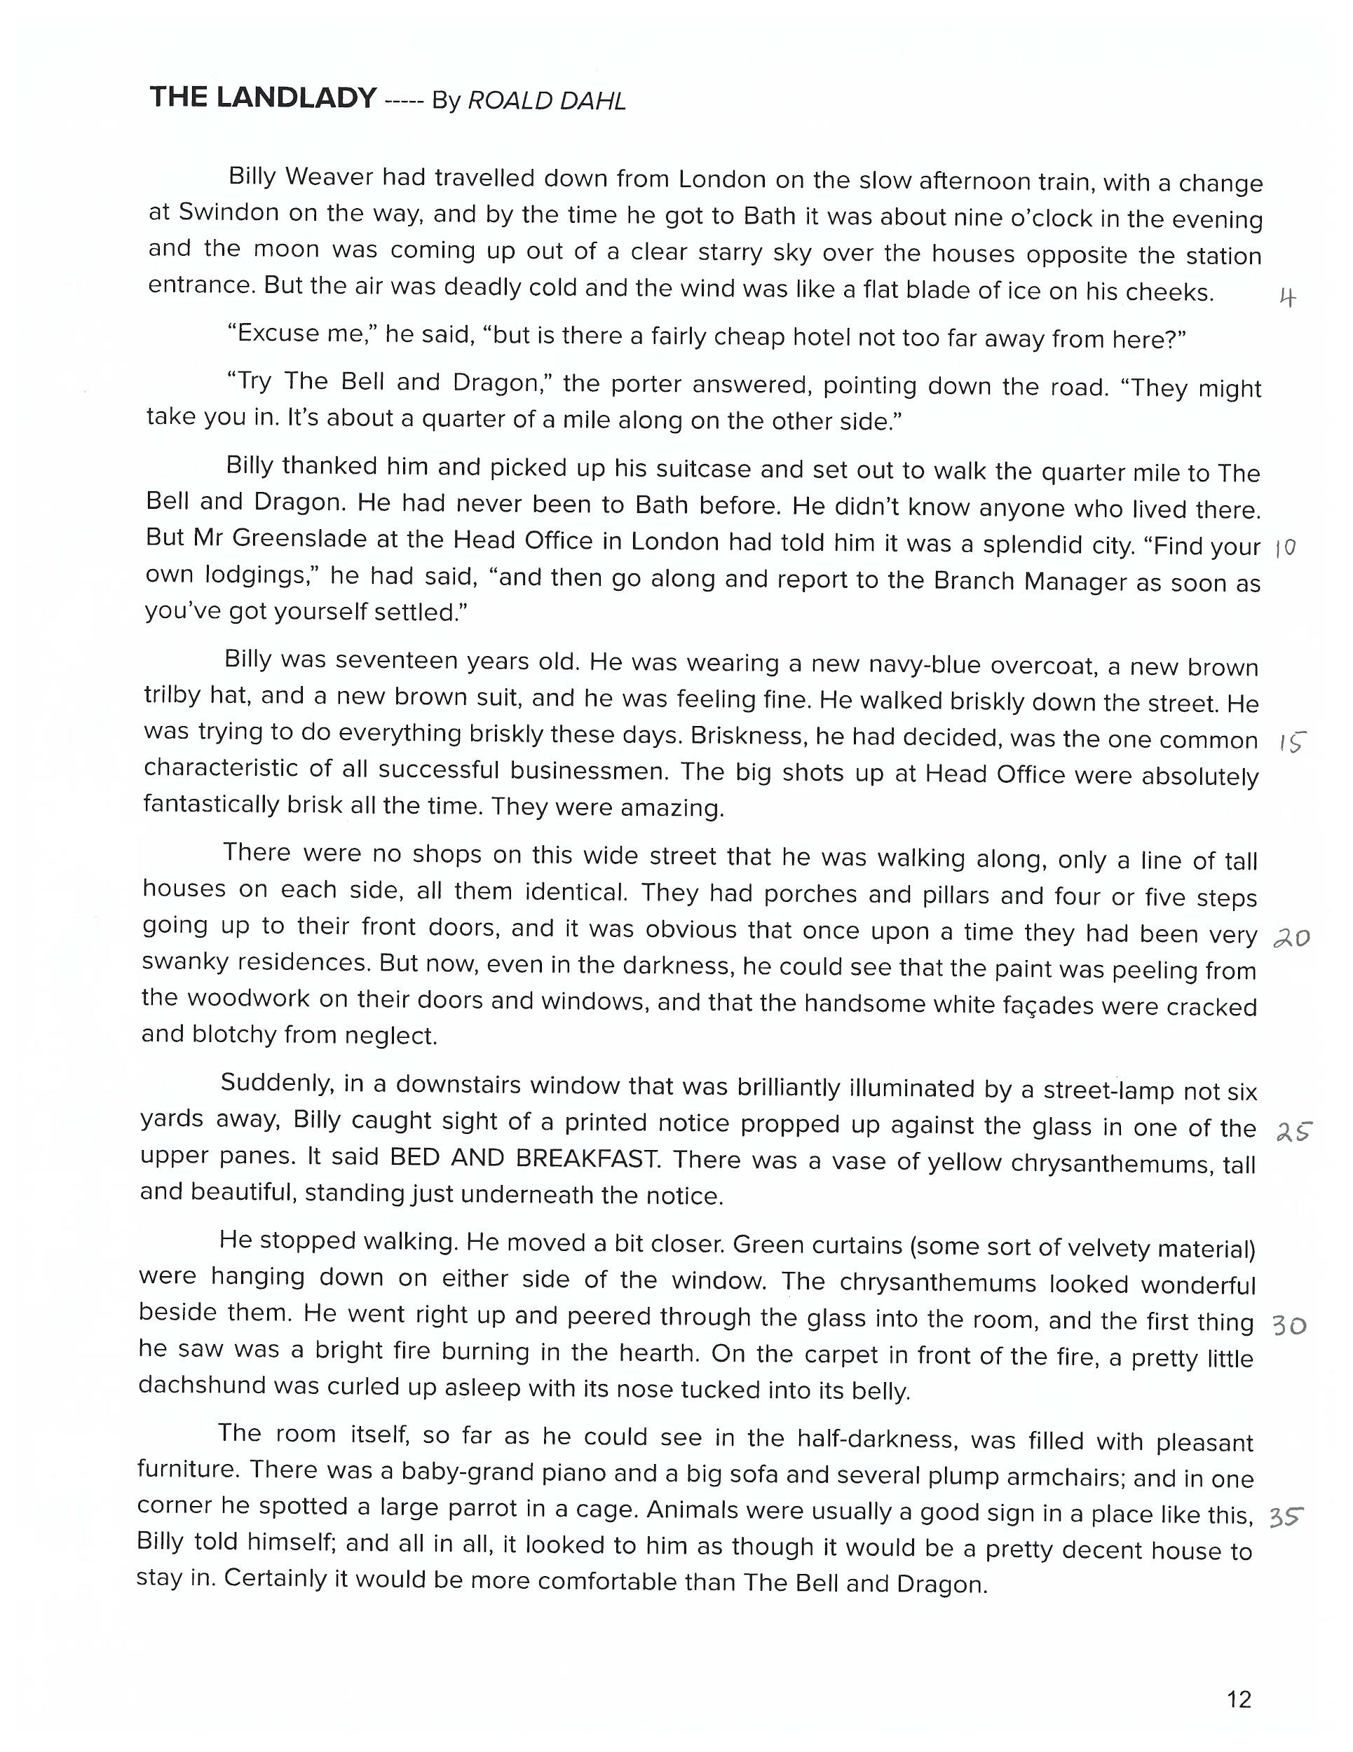

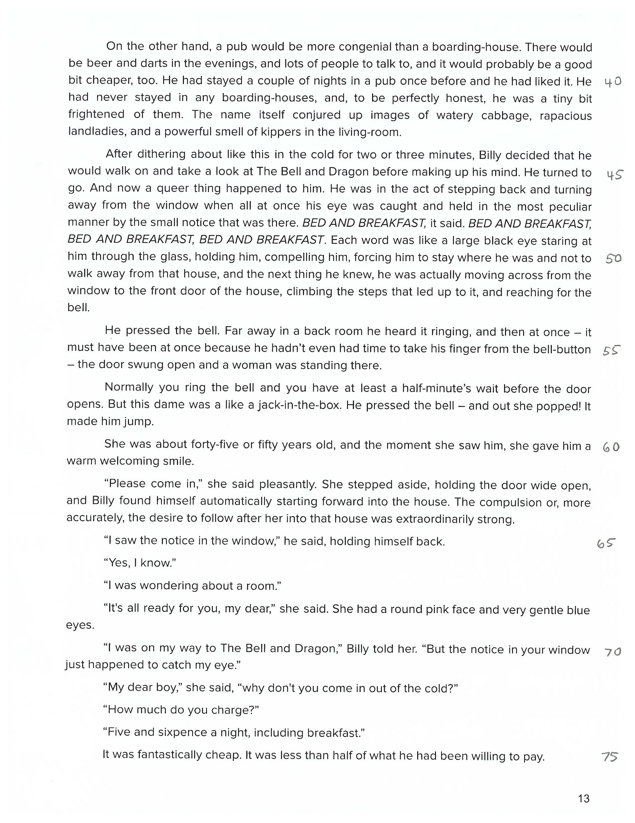

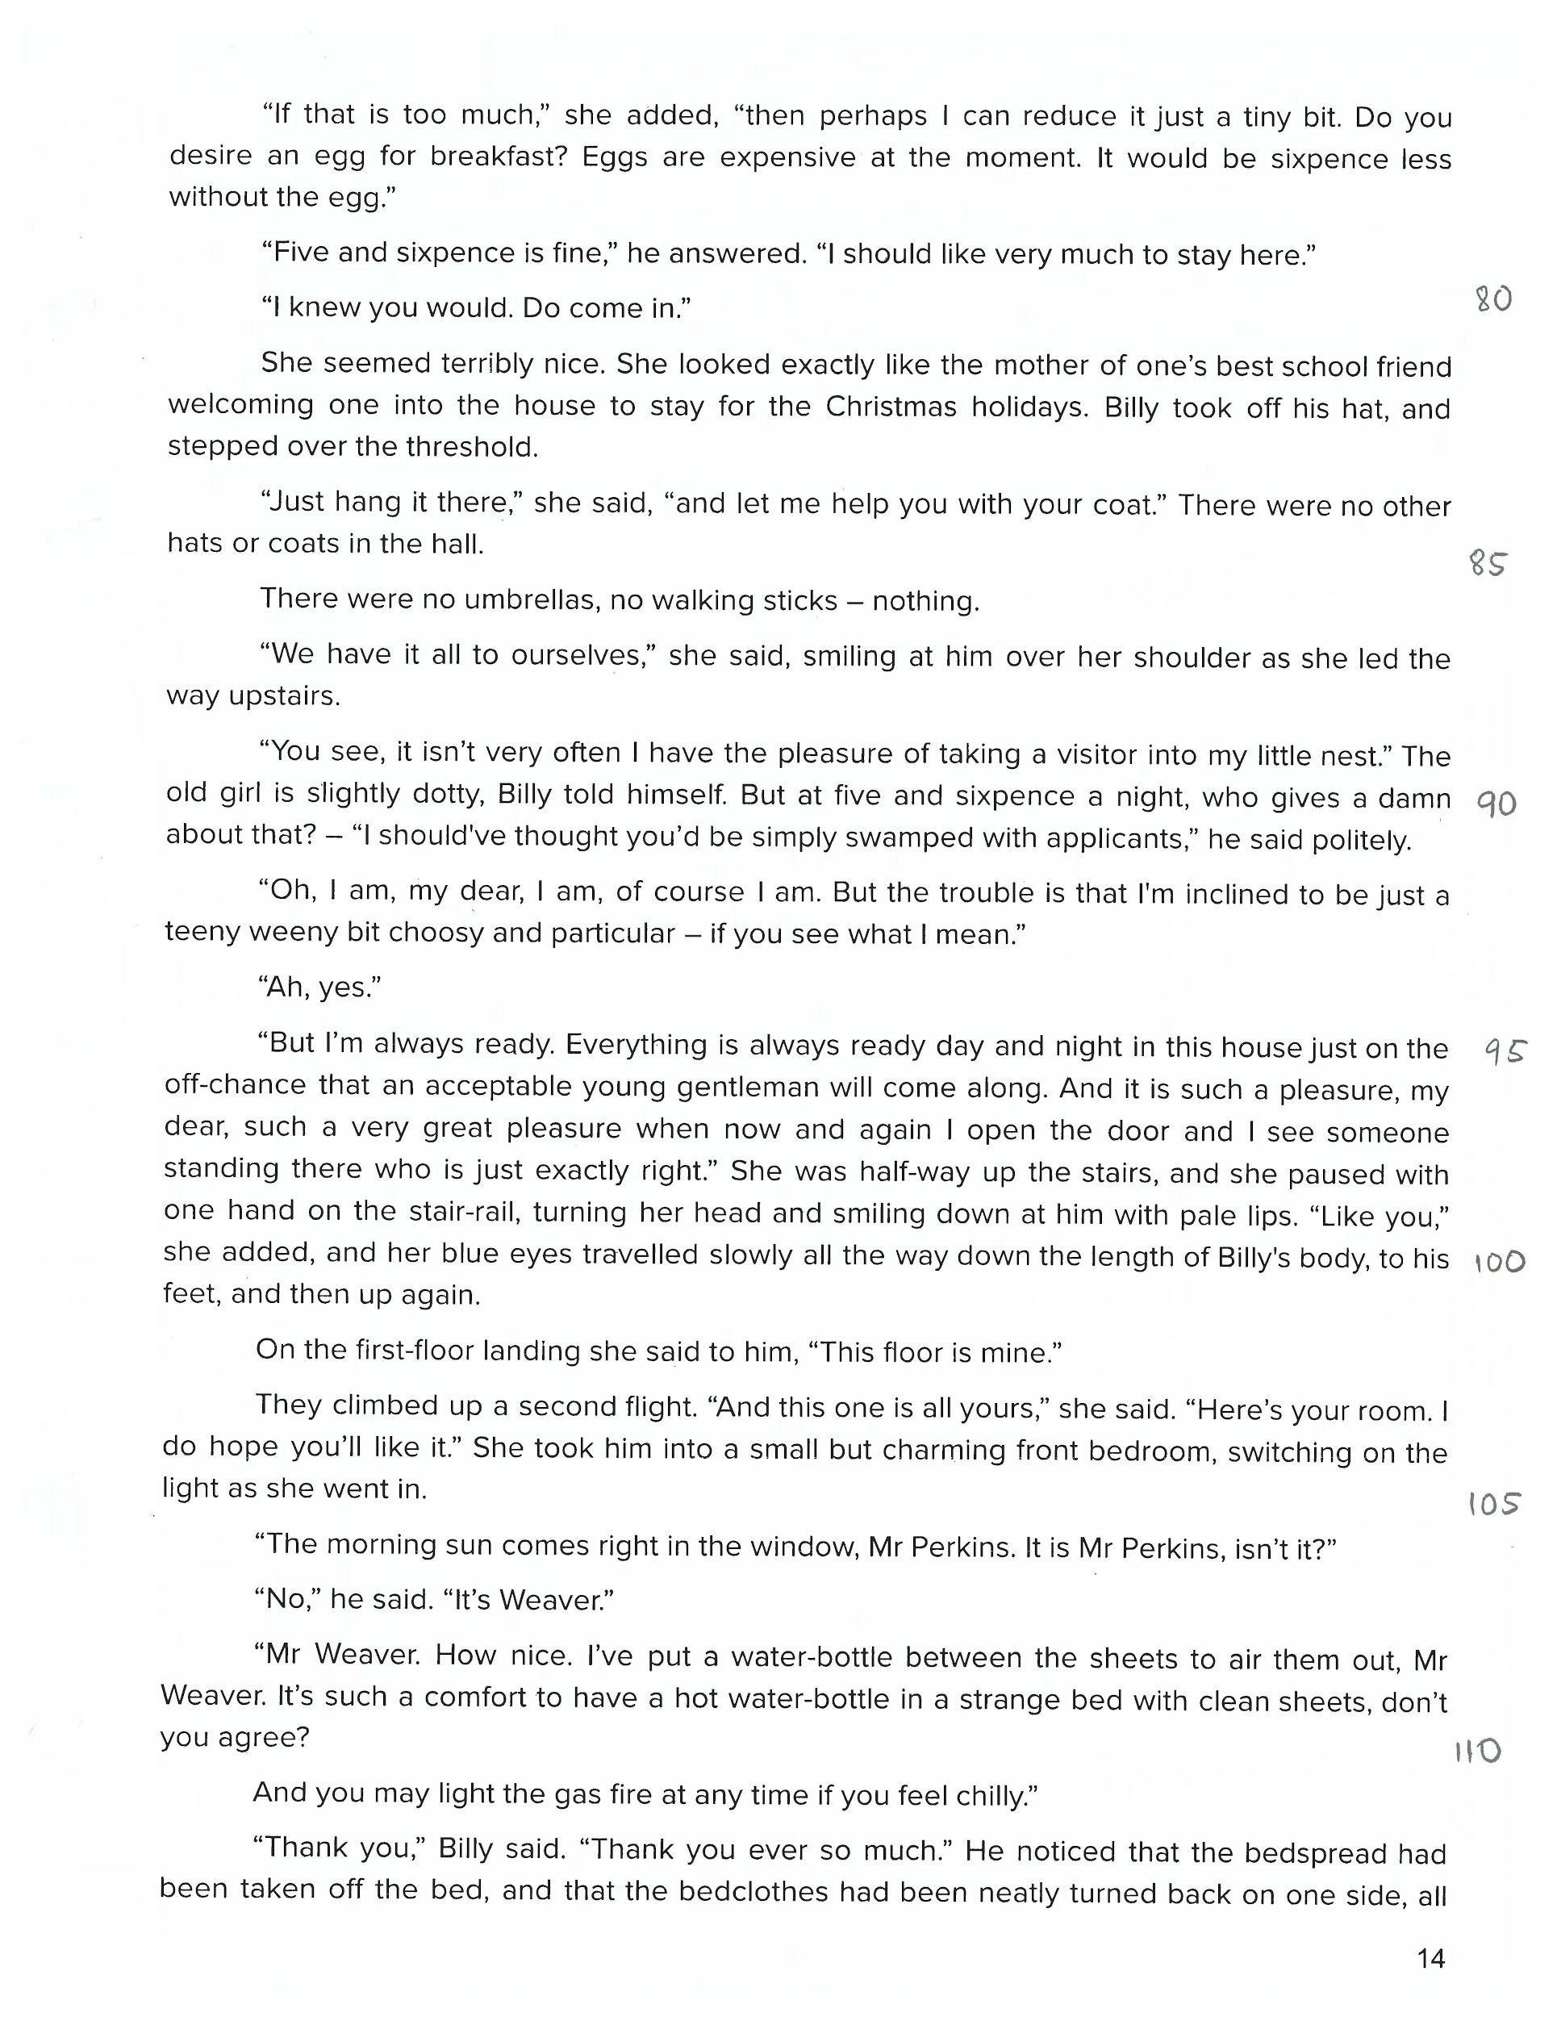

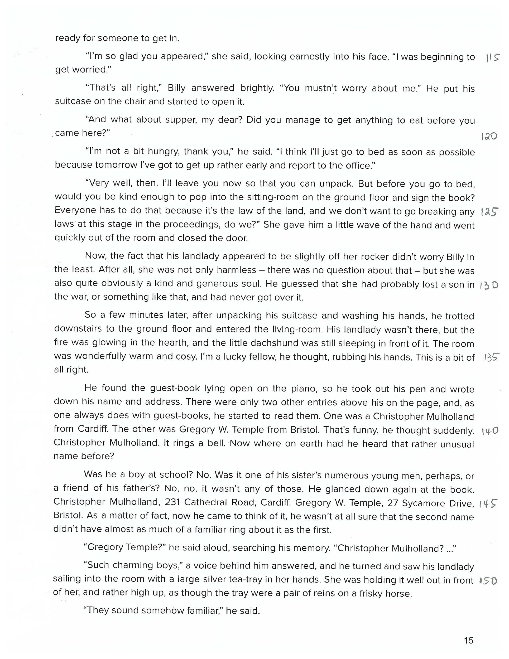

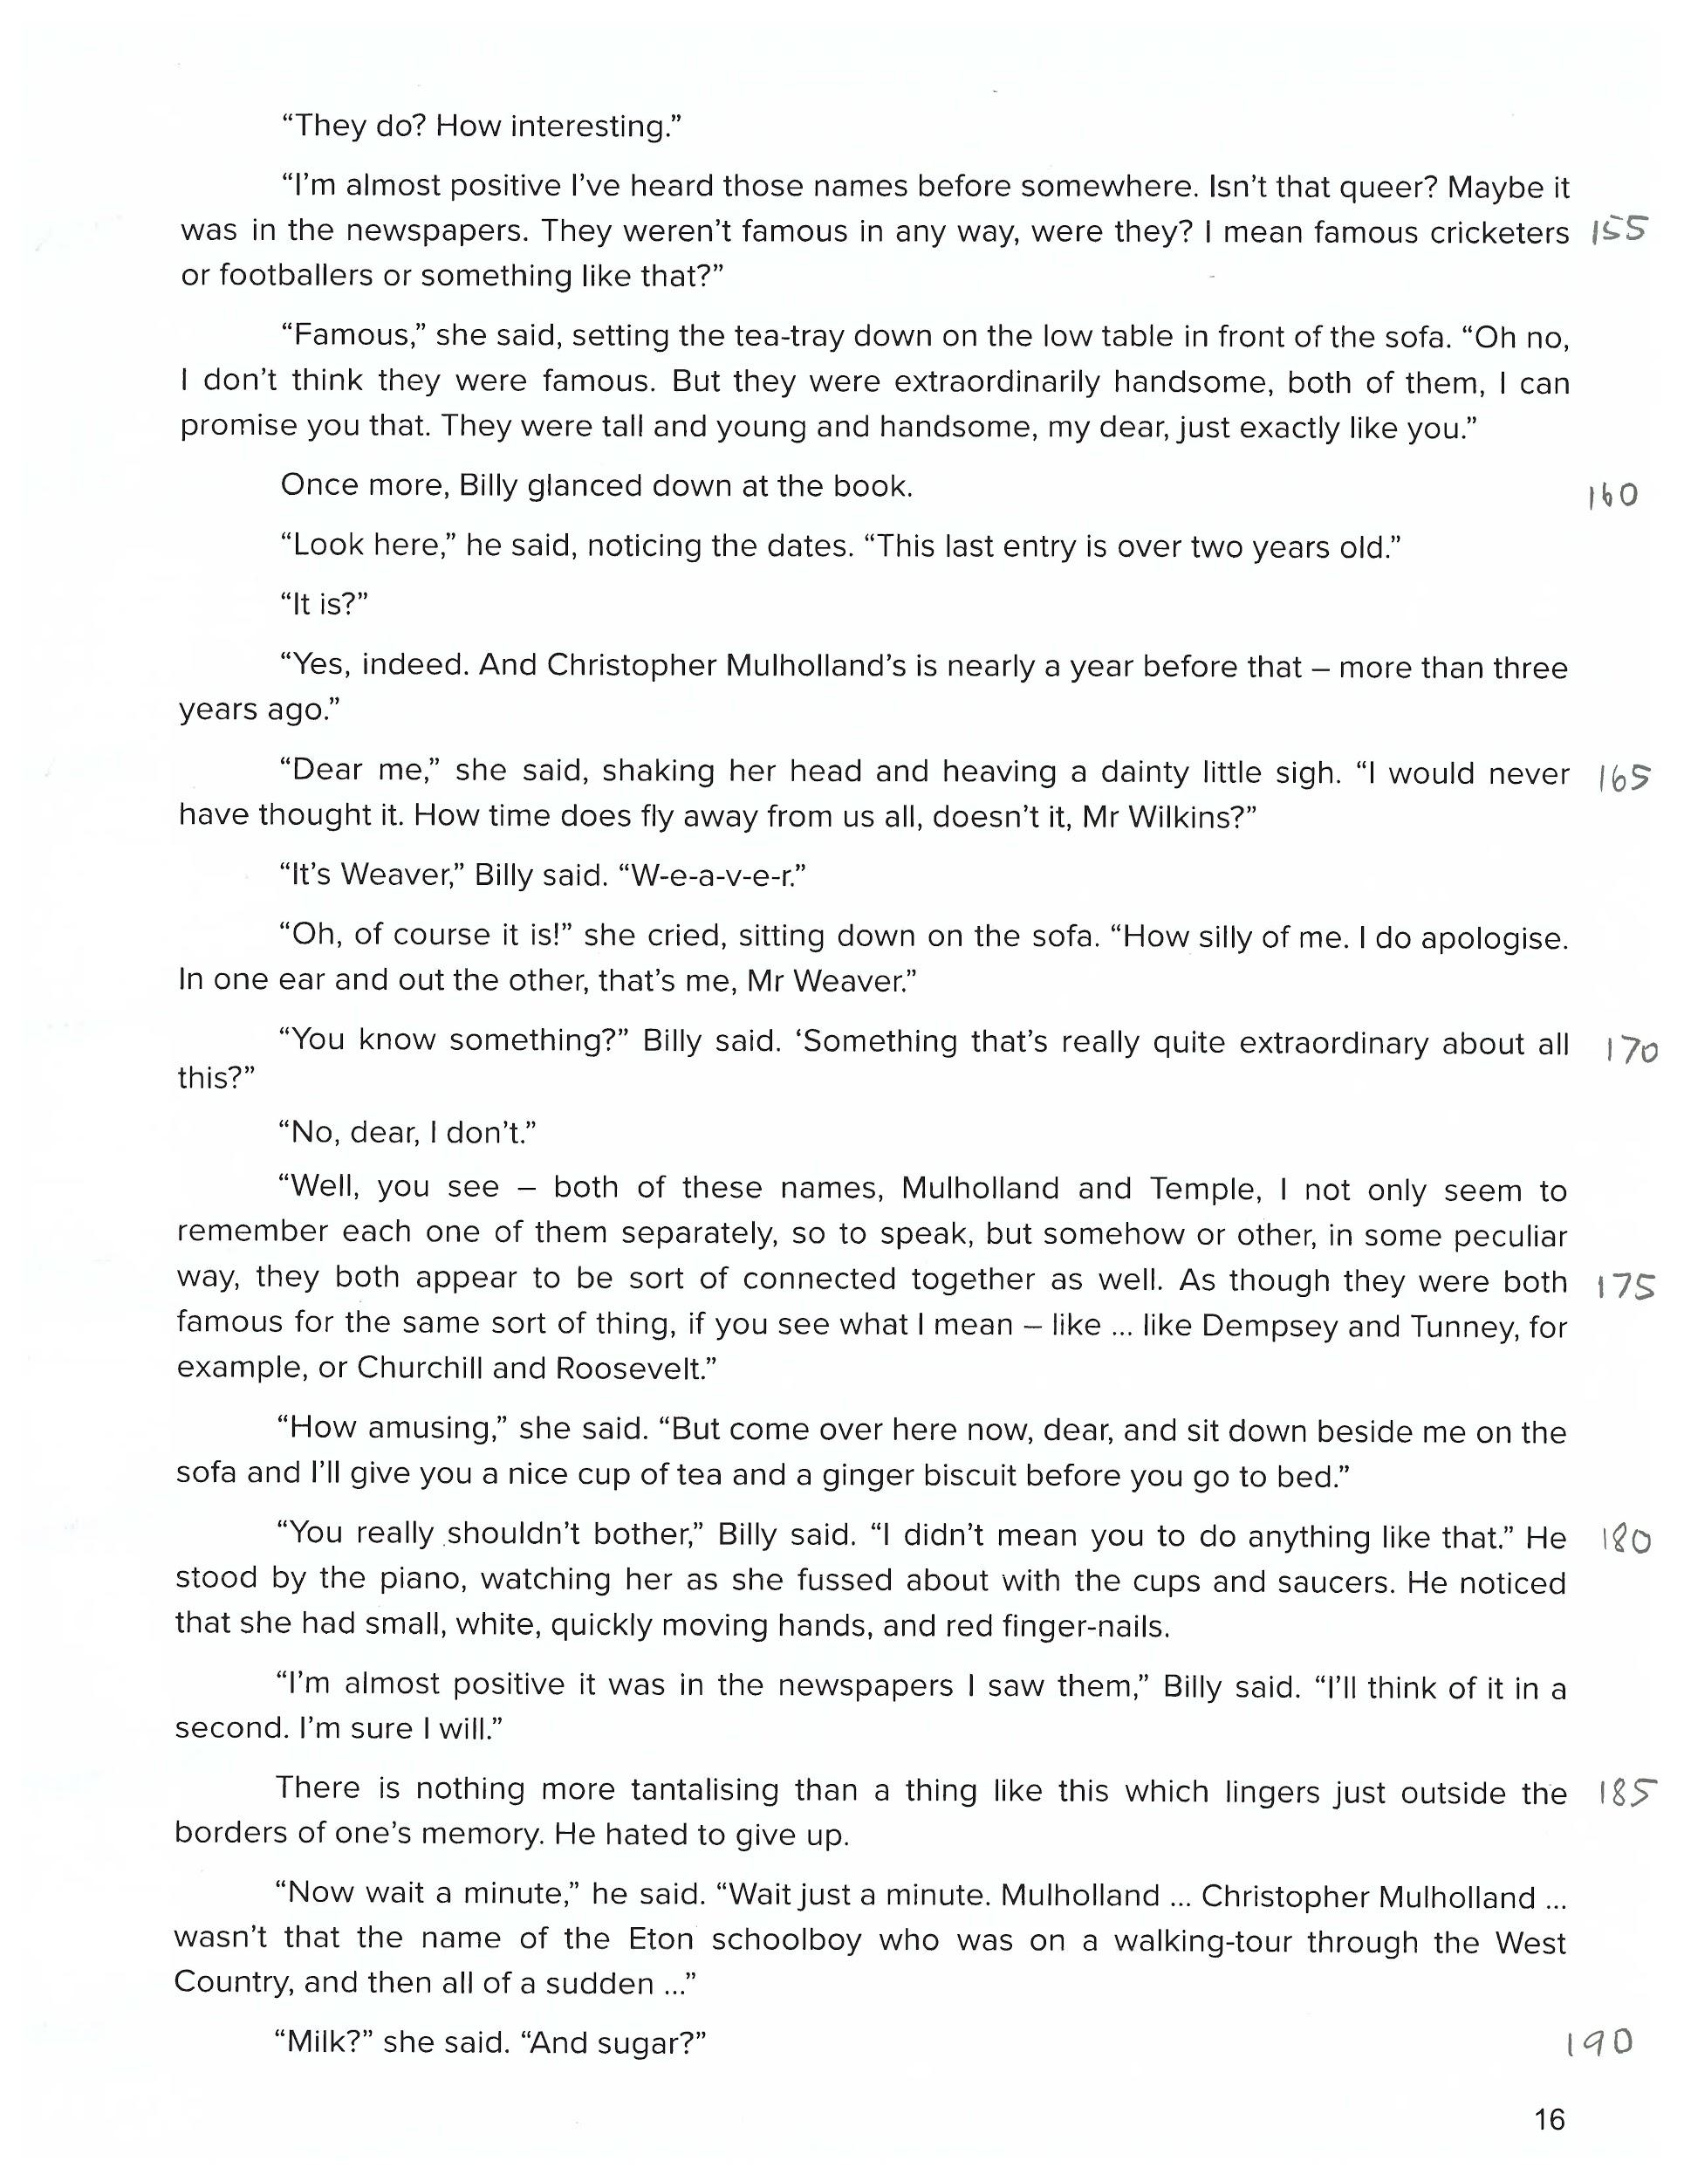

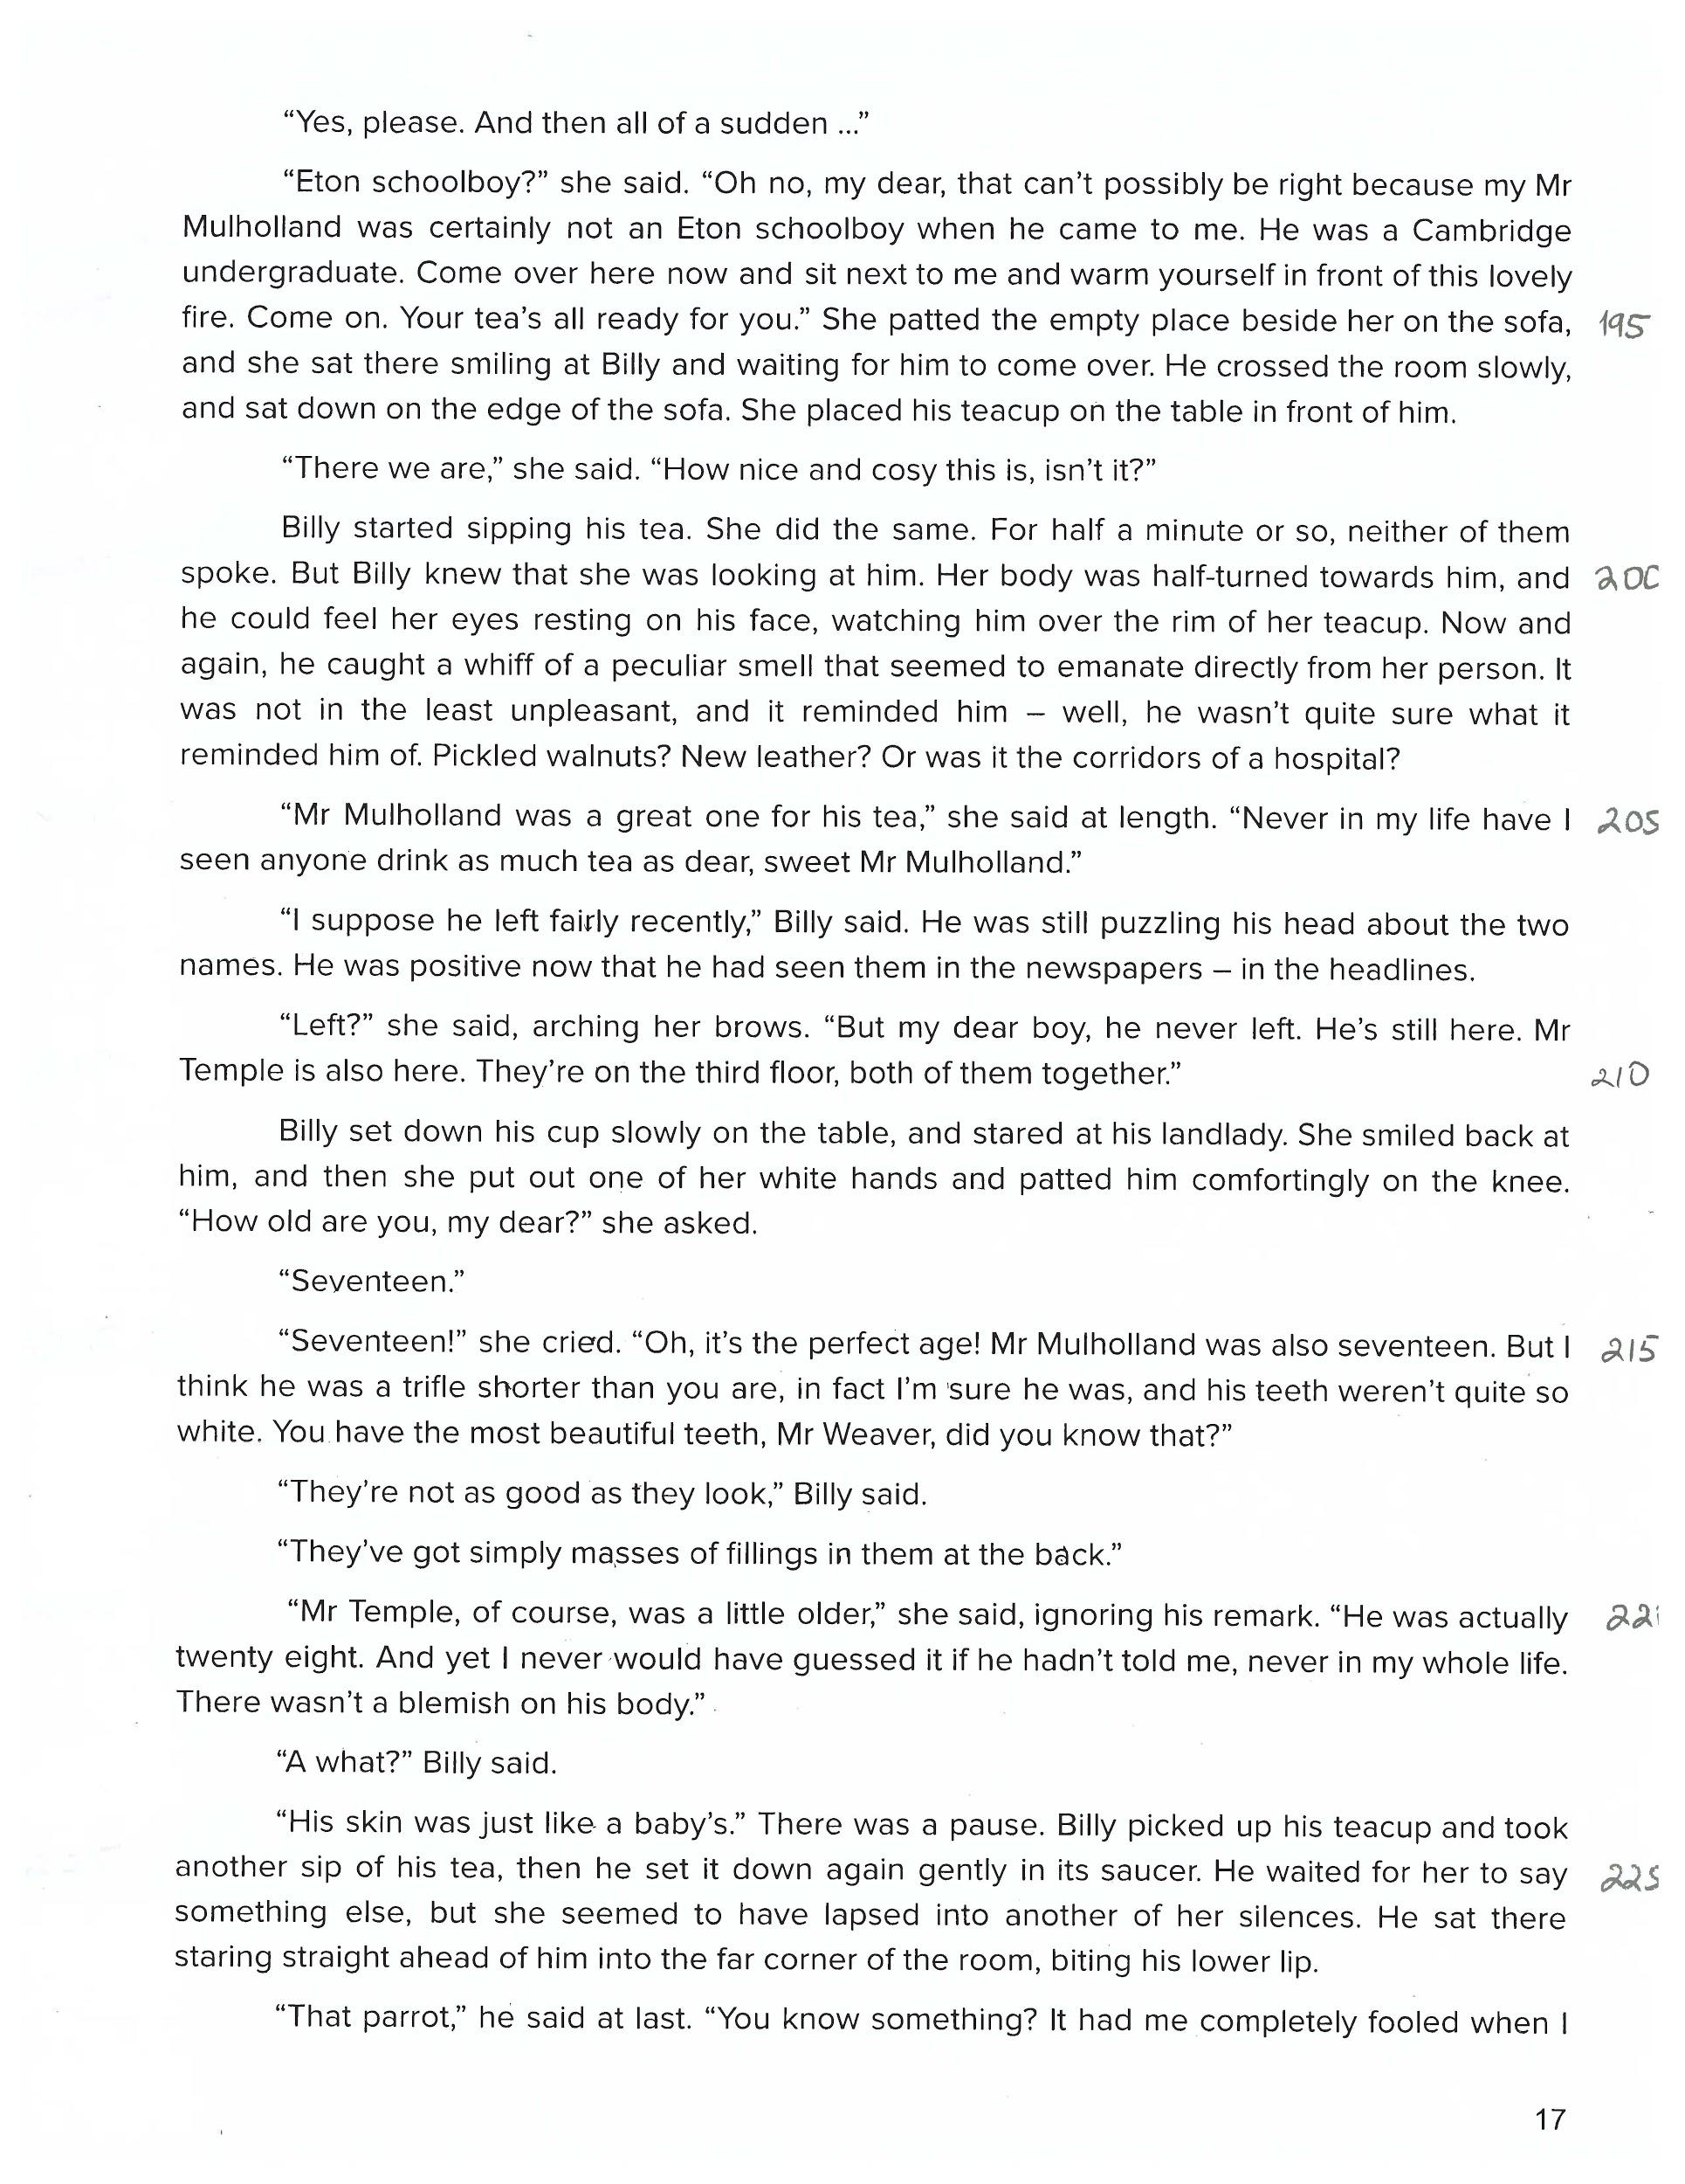

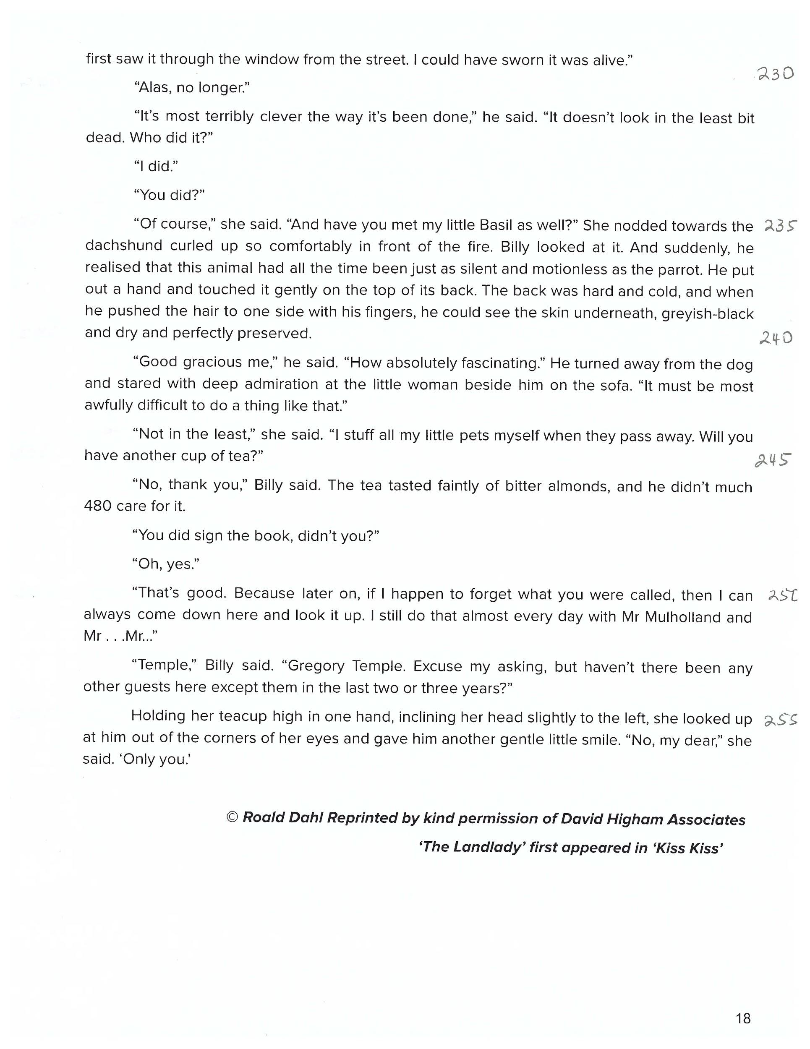

**Harrison Bergeron -** By ***Kurt Vonnegut***

THE YEAR WAS 2081, and everybody was finally equal. They weren't only equal before God and the law. They were equal every which way. Nobody was smarter than anybody else. Nobody was better looking than anybody else. Nobody was stronger or quicker than anybody else. All this equality was due to the 211th, 212th, and 213th Amendments to the Constitution, and to the unceasing vigilance of agents of the United States Handicapper General.

Some things about living still weren't quite right, though. April, for instance, still drove people crazy by not being springtime. And it was in that clammy month that the H-G men took George and Hazel Bergeron's fourteen-year-old son, Harrison, away.

It was tragic, all right, but George and Hazel couldn't think about it very hard. Hazel had a perfectly average intelligence, which meant she couldn't think about anything except in short bursts. And George, while his intelligence was way above normal, had a little mental handicap radio in his ear. He was required by law to wear it at all times. It was tuned to a government transmitter. Every twenty seconds or so, the transmitter would send out some sharp noise to keep people like George from taking unfair advantage of their brains.

George and Hazel were watching television. There were tears on Hazel's cheeks, but she'd forgotten for the moment what they were about.

On the television screen were ballerinas.

A buzzer sounded in George's head. His thoughts fled in panic, like bandits from a burglar alarm.

"That was a real pretty dance, that dance they just did," said Hazel.

"Huh" said George.

"That dance-it was nice," said Hazel.

"Yup," said George. He tried to think a little about the ballerinas. They weren't really very good-no better than anybody else would have been, anyway. They were burdened with sashweights and bags of birdshot, and their faces were masked, so that no one, seeing a free and graceful gesture or a pretty face, would feel like something the cat drug in. George was toying with the vague notion that maybe dancers shouldn't be handicapped. But he didn't get very far with it before another noise in his ear radio scattered his thoughts.

George winced. So did two out of the eight ballerinas.

Hazel saw him wince. Having no mental handicap herself, she had to ask George what the latest sound had been.

"Sounded like somebody hitting a milk bottle with a ball peen hammer," said George.

"I'd think it would be real interesting, hearing all the different sounds," said Hazel a little envious. "All the things they think up."

"Um," said George.

"Only, if I was Handicapper General, you know what I would do?" said Hazel. Hazel, as a matter of fact, bore a strong resemblance to the Handicapper General, a woman named Diana Moon Glampers. "If I was Diana Moon Glampers," said Hazel, "I'd have chimes on Sunday-just chimes. Kind of in honor of religion."

"I could think, if it was just chimes," said George.

"Well-maybe make 'em real loud," said Hazel. "I think I'd make a good Handicapper General."

"Good as anybody else," said George.

"Who knows better than I do what normal is?" said Hazel.

"Right," said George. He began to think glimmeringly about his abnormal son who was now in jail, about Harrison, but a twenty-one-gun salute in his head stopped that.

"Boy!" said Hazel, "that was a doozy, wasn't it?"

It was such a doozy that George was white and trembling, and tears stood on the rims of his red eyes. Two of the eight ballerinas had collapsed to the studio floor, were holding their temples.

"All of a sudden you look so tired," said Hazel. "Why don't you stretch out on the sofa, so's you can rest your handicap bag on the pillows, honeybunch." She was referring to the forty-seven pounds of birdshot in a canvas bag, which was padlocked around George's neck. "Go on and rest the bag for a little while," she said. "I don't care if you're not equal to me for a while."

George weighed the bag with his hands. "I don't mind it," he said. "I don't notice it any more. It's just a part of me."

"You been so tired lately-kind of wore out," said Hazel. "If there was just some way we could make a little hole in the bottom of the bag, and just take out a few of them lead balls. Just a few."

"Two years in prison and two thousand dollars fine for every ball I took out," said George. "I don't call that a bargain."

"If you could just take a few out when you came home from work," said Hazel. "I mean-you don't compete with anybody around here. You just set around."

"If I tried to get away with it," said George, "then other people'd get away with it-and pretty soon we'd be right back to the Dark Ages again, with everybody competing against everybody else. You wouldn't like that, would you?"

"I'd hate it," said Hazel.

"There you are," said George. The minute people start cheating on laws, what do you think happens to society?"

If Hazel hadn't been able to come up with an answer to this question, George couldn't have supplied one. A siren was going off in his head.

"Reckon it'd fall all apart," said Hazel.

"What would?" said George blankly.

"Society," said Hazel uncertainly. "Wasn't that what you just said?

"Who knows?" said George.

The television program was suddenly interrupted for a news bulletin. It wasn't clear at first as to what the bulletin was about, since the announcer, like all announcers, had a serious speech impediment. For about half a minute, and in a state of high excitement, the announcer tried to say, "Ladies and Gentlemen."

He finally gave up, handed the bulletin to a ballerina to read.

"That's all right-" Hazel said of the announcer, "he tried. That's the big thing. He tried to do the best he could with what God gave him. He should get a nice raise for trying so hard."

"Ladies and Gentlemen," said the ballerina, reading the bulletin. She must have been extraordinarily beautiful, because the mask she wore was hideous. And it was easy to see that she was the strongest and most graceful of all the dancers, for her handicap bags were as big as those worn by two-hundred pound men.

And she had to apologize at once for her voice, which was a very unfair voice for a woman to use. Her voice was a warm, luminous, timeless melody. "Excuse me-" she said, and she began again, making her voice absolutely uncompetitive.

"Harrison Bergeron, age fourteen," she said in a grackle squawk, "has just escaped from jail, where he was held on suspicion of plotting to overthrow the government. He is a genius and an athlete, is under-handicapped, and should be regarded as extremely dangerous."

A police photograph of Harrison Bergeron was flashed on the screen-upside down, then sideways, upside down again, then right side up. The picture showed the full length of Harrison against a background calibrated in feet and inches. He was exactly seven feet tall. The rest of Harrison's appearance was Halloween and hardware. Nobody had ever born heavier handicaps. He had outgrown hindrances faster than the H-G men could think them up. Instead of a little ear radio for a mental handicap, he wore a tremendous pair of earphones, and spectacles with thick wavy lenses. The spectacles were intended to make him not only half-blind, but to give him whanging headaches besides.

Scrap metal was hung all over him. Ordinarily, there was a certain symmetry, a military neatness to the handicaps issued to strong people, but Harrison looked like a walking junkyard. In the race of life, Harrison carried three hundred pounds.

And to offset his good looks, the H-G men required that he wear at all times a red rubber ball for a nose, keep his eyebrows shaved off, and cover his even white teeth with black caps at snaggletooth random.

"If you see this boy," said the ballerina, "do not - I repeat, do not - try to reason with him."

There was the shriek of a door being torn from its hinges.

Screams and barking cries of consternation came from the television set. The photograph of Harrison Bergeron on the screen jumped again and again, as though dancing to the tune of an earthquake.

George Bergeron correctly identified the earthquake, and well he might have - for many was the time his own home had danced to the same crashing tune. "My God-" said George, "that must be Harrison!"

The realization was blasted from his mind instantly by the sound of an automobile collision in his head.

When George could open his eyes again, the photograph of Harrison was gone. A living, breathing Harrison filled the screen.

Clanking, clownish, and huge, Harrison stood - in the center of the studio. The knob of the uprooted studio door was still in his hand. Ballerinas, technicians, musicians, and announcers cowered on their knees before him, expecting to die.

"I am the Emperor!" cried Harrison. "Do you hear? I am the Emperor! Everybody must do what I say at once!" He stamped his foot and the studio shook.

"Even as I stand here" he bellowed, "crippled, hobbled, sickened - I am a greater ruler than any man who ever lived! Now watch me become what I can become!"

Harrison tore the straps of his handicap harness like wet tissue paper, tore straps guaranteed to support five thousand pounds.

Harrison's scrap-iron handicaps crashed to the floor.

Harrison thrust his thumbs under the bar of the padlock that secured his head harness. The bar snapped like celery. Harrison smashed his headphones and spectacles against the wall.

He flung away his rubber-ball nose, revealed a man that would have awed Thor, the god of thunder.

"I shall now select my Empress!" he said, looking down on the cowering people. "Let the first woman who dares rise to her feet claim her mate and her throne!"

A moment passed, and then a ballerina arose, swaying like a willow.

Harrison plucked the mental handicap from her ear, snapped off her physical handicaps with marvelous delicacy. Last of all he removed her mask.

She was blindingly beautiful.

"Now-" said Harrison, taking her hand, "shall we show the people the meaning of the word dance? Music!" he commanded.

The musicians scrambled back into their chairs, and Harrison stripped them of their handicaps, too. "Play your best," he told them, "and I'll make you barons and dukes and earls."

The music began. It was normal at first-cheap, silly, false. But Harrison snatched two musicians from their chairs, waved them like batons as he sang the music as he wanted it played. He slammed them back into their chairs.

The music began again and was much improved.

Harrison and his Empress merely listened to the music for a while-listened gravely, as though synchronizing their heartbeats with it.

They shifted their weights to their toes.

Harrison placed his big hands on the girl’s tiny waist, letting her sense the weightlessness that would soon be hers.

And then, in an explosion of joy and grace, into the air they sprang!

Not only were the laws of the land abandoned, but the law of gravity and the laws of motion as well.

They reeled, whirled, swiveled, flounced, capered, gamboled, and spun.

They leaped like deer on the moon.

The studio ceiling was thirty feet high, but each leap brought the dancers nearer to it. It became their obvious intention to kiss the ceiling.

They kissed it.

And then, neutralizing gravity with love and pure will, they remained suspended in air inches below the ceiling, and they kissed each other for a long, long time.

It was then that Diana Moon Glampers, the Handicapper General, came into the studio with a double-barreled ten-gauge shotgun. She fired twice, and the Emperor and the Empress were dead before they hit the floor.

Diana Moon Glampers loaded the gun again. She aimed it at the musicians and told them they had ten seconds to get their handicaps back on.

It was then that the Bergerons' television tube burned out.

Hazel turned to comment about the blackout to George.

But George had gone out into the kitchen for a can of beer.

George came back in with the beer, paused while a handicap signal shook him up. And then he sat down again. "You been crying" he said to Hazel.

"Yup," she said.

"What about?" he said.

"I forget," she said.

"Something real sad on television."

"What was it?" he said.

"It's all kind of mixed up in my mind," said Hazel.

"Forget sad things," said George.

"I always do," said Hazel.

"That's my girl," said George. He winced. There was the sound of a riveting gun in his head.

"Gee - I could tell that one was a doozy," said Hazel.

"You can say that again," said George.

"Gee-" said Hazel, "I could tell that one was a doozy."