 **Santa Clara Adult Education**

**Adult High School Diploma Program**

**WORLD HISTORY**

**SEMESTER A**

***Name:*** *_______________________________________________*

**11/2018**

**World History Semester A Syllabus - *(5 Credits)***

Programmed Logic for Automated Teaching Operations (PLATO)

Worksheets from McDougal/Littel Modern World History

**To access Youtube links, you must sign in on the computer using**

**the Username of GED and the Password of password.**

*PLATO log-in:* <https://ple.platoweb.com>

*Account login:* ***SCAS1***

*User name:* ***first initial, last name***

*Password:* ***password***

* ***If this is your first PLATO class, you must start with the Student Orientation. Otherwise you may skip it.***
* ***Many web pages throughout the tutorials require you to type an answer, click “Submit”, and self-correct. Do all of these unless the syllabus says to skip them.***
* ***On pages you skip, you may need to type an X in the blank assignment in order to progress to the next page.***
* ***Remember, some pages need to be printed and handed in to your teacher.***

**PLATO World History A**

**Unit 1: *Historical Thinking Skills***

Primary and Secondary Sources Tutorial: pages 8-14, 17-22, 24-35, 37-38

NO Mastery Test

Historiography Tutorial: pages 8-33 On page 32, do Part A only, then print and give to your teacher.

NO Mastery Test

Historical Data Tutorial: pages 6-37

NO Mastery test

**Unit 2: *The Age of European Exploration***

Exploration and Technology Tutorial: Do all.

Do Mastery Test

Exploration and Conquest Tutorial: Do all. Print your completed work on page 32 and give to your teacher.

Do Mastery Test

Exploration and Economic Development Tutorial: Begin on page 5, skip page 6, do pages 7-15. Skip page 16 and instead do the sheet attached to this syllabus, “Impact of the Columbian Exchange”, and give to teacher. Continue pages 17 to the end.

Do Mastery Test

The Slave Trade and Colonization Tutorial: Do all.

Print page 25 when completed and give to teacher.

Do Mastery Test

**Unit 3: *The Renaissance and the Reformation***

***Renaissance Culture Tutorial:***

Page 5, skip page 6, then continue from page 7-25.

Skip page 26 and instead watch the two youtube videos

Leonardo, Michelangelo, Raphael by Uriy Kiba

<https://www.youtube.com/watch?v=33JtwMfyxkU> and

AWESOME Inventions by Leonardo Da Vinci! By Origins Explained

<https://www.youtube.com/watch?v=_uhMiXmN9Dk>

Continue from page 27 to page 48, do the assignment there, print and give to your teacher. Continue to the end. Do Mastery Test

***The Reformation:***

Causes and Effects Tutorial: pages 1-23, skip page 24, do 25-end. Do Mastery Test

***Counter-Reformation Tutorial:***

Skip pages 6,31, 38. NO test

***English Civil War and Glorious Revolution Tutorial:***

Skip page 6. On page 37, do Part A only, print and give to your teacher. Do Mastery Test

**Unit 4: *The Age of Revolution***

***Scientific Revolution Tutorial***:

Pages 7-40, 43. Do Mastery Test.

***Enlightenment Tutorial:***

pages 7-37, 40. Do Mastery Test.

***American Revolution Tutorial:***

pages 5,7-29, 32. Do Mastery Test.

***French Revolution Tutorial:***

Pages 5, 6 (answer on paper), 7-26, 28-34

Now complete the sheet attached to this syllabus, “Comparing Revolutions in America and France” and turn in to teacher. Do Mastery Test.

***Napoleonic Period Tutorial:***

Pages 5-12, 15-37, 40. Do Mastery Test

***Latin American Tutorial:***

Pages 5, 6 (answer on paper), 7-14, 17-32, 35. Do Mastery Test.

***Agricultural Revolution Tutorial:***

pages 5, 7-17, 19-27. Do Mastery Test.

***Industrial Revolution Tutorial:***

pages 7-20, 21 Parts A and B, 22-40. Do Mastery Test.

**Unit 5: *The Rise of Industry and Nationalism***

***The Rise of Nationalism Tutorial:***

Skip page 6.

After page 20, complete the sheet “Napoleon” attached to this syllabus and give to teacher. After page 25, do the sheet “Congress of Vienna” attached to this syllabus and give to teacher.

Skip page 36. Do Mastery Test.

***Russia’s Transition to the Industrial Age Tutorial:***

Skip page 6. Print page 43 when completed and give to teacher.

Do Mastery Test.

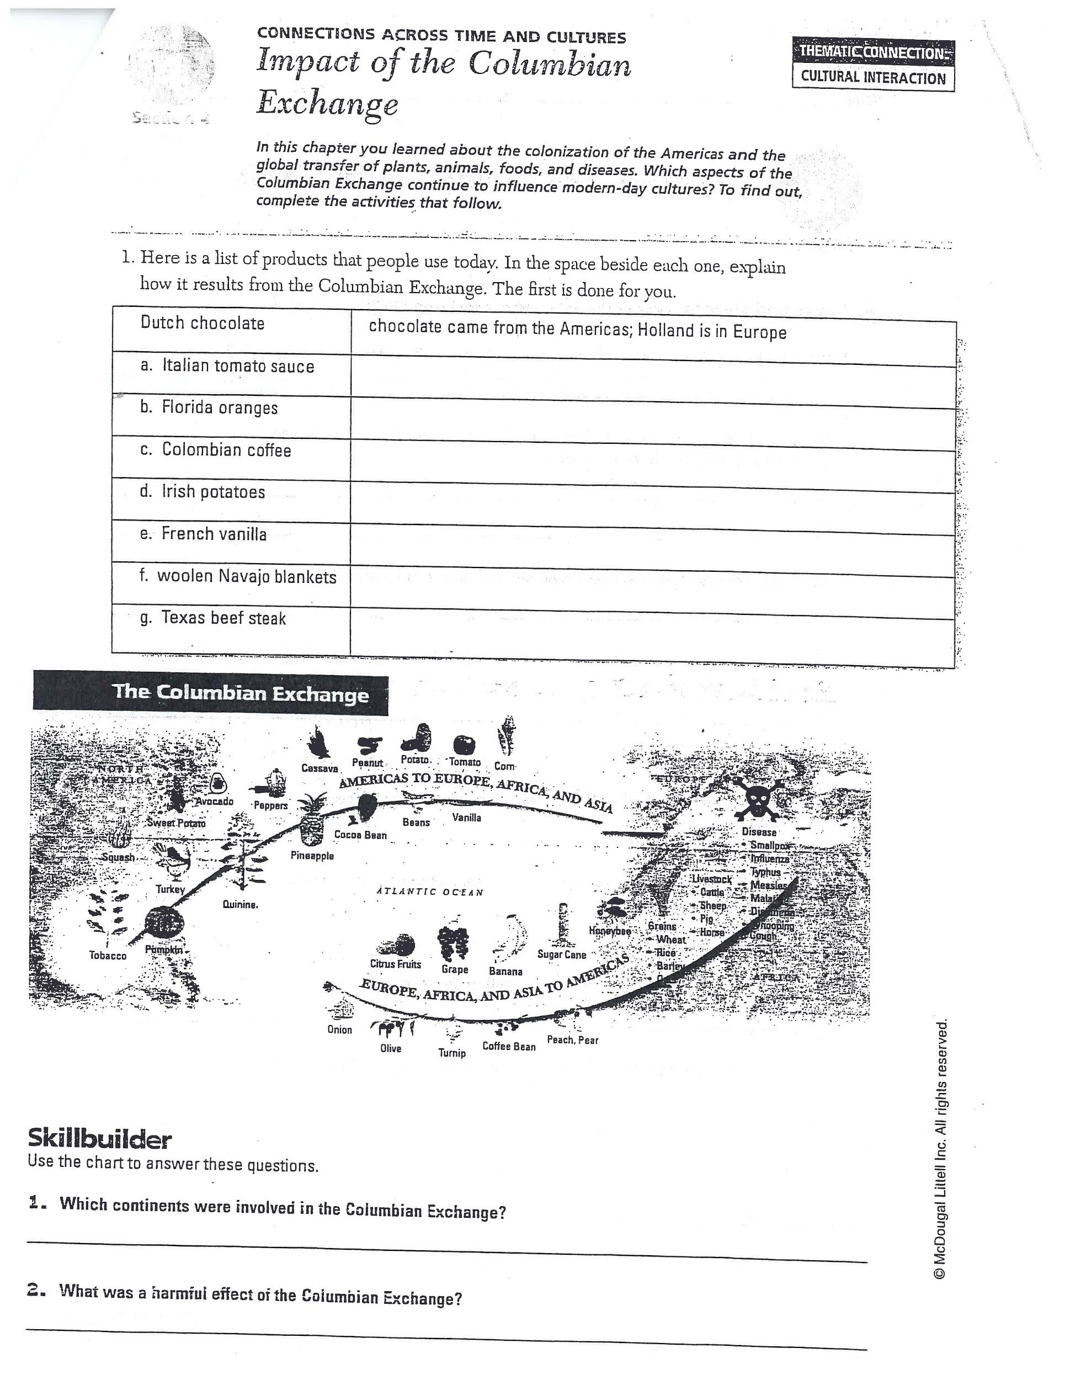

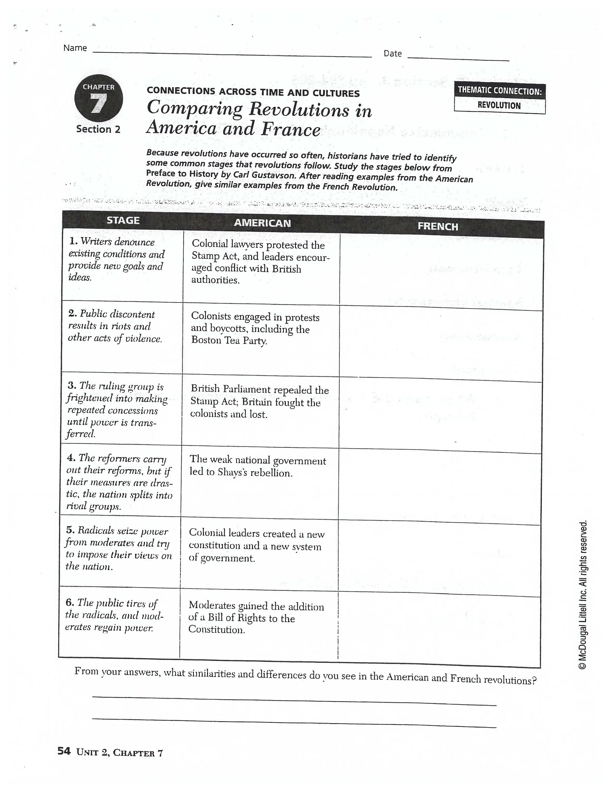

***NAPOLEON -*** *CHAPTER 7, SECTION 3 - (Pg. 204 - 208)*

1. Summarize Napoleon’s reforms in France
2. A (law)
3. (tax)
4. (economy)
5. (government)
6. (equal opportunity)
7. (education)
8. (religion)

**2**. What step did Napoleon take to create an empire in Europe?

*Define the following terms:*

Estate

Declaration of the Rights of Men

Coup d’etat

***CONGRESS OF VIENNA-***

*CHAPTER 7, SECTION 5 - (Pg. 213 -217)*

1. What were Metternich’s three goals at the Congress of Vienna?

***A.***

***B.***

***C***.

**2**. How did the Congress of Vienna ensure peace in Europe for the next 38 years?

**World History A**

**Record Sheet/Student Grades - Name:** ______________________________

|  |  |  |  |  |
| --- | --- | --- | --- | --- |
| **Unit 1:**  ***Historical Thinking Skills*** | ***Date*** | ***Hrs.*** | ***Grade*** | ***Teacher Initial*** |
| **Primary and Secondary Sources Tutorial** |  |  |  |  |
| **Historiography Tutorial**   * Page 32, Part A |  |  |  |  |

|  |  |  |  |  |
| --- | --- | --- | --- | --- |
| **Unit 2: *The Age of European Exploration*** | ***Date*** | ***Hrs.*** | ***Grade*** | ***Teacher Initial*** |
| **Exploration & Technology Tutorial**   * Mastery Test |  |  |  |  |
| **Exploration & Conquest Tutorial**   * Page 32 * Mastery Test |  |  |  |  |
| **Exploration and Economic Development Tutorial**   * Worksheet “Impact of the Columbian Exchange” * Mastery Test |  |  |  |  |
| **The Slave Trade & Colonization Tutorial**   * Page 25 * Mastery Test |  |  |  |  |

|  |  |  |  |  |
| --- | --- | --- | --- | --- |
| **Unit 3: *The Renaissance and***  ***The Reformation*** | ***Date*** | ***Hrs.*** | ***Grade*** | ***Teacher Initial*** |
| **Renaissance Culture Tutorial**   * Page 48, * 2 videos * Mastery Test |  |  |  |  |
| **The Reformation**   * Causes and Effects Tutorial * Mastery Test |  |  |  |  |
| ***Counter-Reformation Tutorial*** |  |  |  |  |
| **English Civil War and Glorious Revolution Tutorial**   * Page 37, Part A * Mastery Test |  |  |  |  |

|  |  |  |  |  |
| --- | --- | --- | --- | --- |
| **Unit 4: *The Age of Revolution*** | ***Date*** | ***Hrs*** | ***Grade*** | ***Teacher Initial*** |
| **Scientific Revolution Tutorial**   * Mastery Test. |  |  |  |  |
| **Enlightenment Tutorial**   * Mastery Test. |  |  |  |  |
| **American Revolution Tutorial**   * Mastery Test. |  |  |  |  |
| **French Revolution Tutorial**   * Page 6 * Worksheet “Comparing Revolutions in America & France” * Mastery Test |  |  |  |  |
| **Napoleonic Period Tutorial**   * Mastery Test |  |  |  |  |
| **Latin American Tutorial**   * Page 6 * Mastery Test |  |  |  |  |
| **Agricultural Revolution Tutorial**   * Mastery Test |  |  |  |  |
| **Industrial Revolution Tutorial**   * Mastery Test |  |  |  |  |

|  |  |  |  |  |
| --- | --- | --- | --- | --- |
| **Unit 5: *The Rise of Industry and Nationalism*** | ***Date*** | ***Hrs.*** | ***Grade*** | ***Teacher Initial*** |
| **The Rise of Nationalism Tutorial**   * Worksheet “Napoleon” * Worksheet “Congress of Vienna” * Mastery Test |  |  |  |  |
| **Russia’s Transition to the Industrial Age Tutorial**   * Page 43 * Mastery Test |  |  |  |  |

**Final Grade:** ______________________________________________________