 **Santa Clara Adult Education**

**Adult High School Diploma Program**

**WORLD HISTORY**

**SEMESTER B**

***Name:*** *_______________________________________________*

**11/2018**

**World History Semester B (Blended) Syllabus**

Modern World History (McDougal/Littel) text;

Programmed Logic for Automated Teaching Operations (PLATO)

5 Credits

PLATO log-in: <https://ple.platoweb.com>

*Account login:* ***SCAS1***

*User name:* ***first initial, last name***

*Password:* ***password***

* **Read all the assignments below carefully. Check with your teacher if you don’t understand what to do.**
* **If this is your first PLATO class, you must start with the Student Orientation. Otherwise you may skip it.**
* **Many web pages throughout the tutorials require you to type an answer, click “Submit”, and self-correct. Do all of these unless the syllabus says to skip them.**
* **On pages you skip, you may need to type an X in the blank assignment in order to progress to the next page.**
* **Remember, some pages need to be printed and handed in to your teacher.**
* **To access Youtube links, you must sign in on the computer using the Username of GED and the Password of password.**

**PLATO World History B**

**Unit 1: *Imperialism and World War I***

**The Rush for Empire Tutorial:**

Do all except p6 and 31-36.

Do Mastery Test.

**Imperialism in East Asia, India and the Pacific Tutorial:**

Do all except p6 and 45.

Do Mastery Test

**Imperialism in Africa, the Middle East, and Latin America Tutorial:**

Do all except p6, 10 and 33.

After p20, read and answer the questions on the attached Primary Source: Letter from Menelik II; give to teacher.

After p28, do the attached Genocide assignment; give to teacher.

Do Mastery Test.

**The Great War Tutorial:**

Do all except p6 and 21.

Give your p23 answers to teacher.

After p39 do the questions on the attached Zimmerman Note; give to teacher.

On p44 do questions on the chart link.

Do Mastery Test.

**World War I Ends Tutorial:**

After p17 do the questions on the attached Treaty of Versailles Primary Source; turn in to teacher.

After p23, do the attached John Maynard Keynes assignment; turn in to teacher.

When you reach p29, instead of the video on the page, watch these youtubes:

# Duke Ellington and his Orchestra - Take The A Train (1962) [official video] StoryvilleRecords

<https://www.youtube.com/watch?v=D6mFGy4g_n8>

# Fats Waller I´m gonna sit right down and write myself a letter

### 

### [Zedupoca](https://www.youtube.com/channel/UCrKezjKEPRRHS-tqBiNHr0g)

<https://www.youtube.com/watch?v=8ZZRAU3DeOo>

**Unit 2: *World War II***

**Between the Wars Tutorial:**

Do all. On p 6 think about the questions.

After p 23, watch this youtube:

# More Than Gold: Jesse Owens and The 1936 Berlin Olympics - Trailer [NBC Sports](https://www.youtube.com/channel/UCqZQlzSHbVJrwrn5XvzrzcA)

<https://www.youtube.com/watch?v=yf6ryOWfYN4&list=PLm3MksY821P5YbALtWak3G-A_v1bbmeqm&index=25>

After p38 answer the questions on the attached Need for Progress (Stalin) paper.

On p51, give your answers to your teacher.

Do Mastery Test

**War Breaks Out Tutorial:**

Do all except p 50.

On p6, write out your answers regarding a free press; give to teacher.

After p 13, watch this youtube:

Kristallnacht: Night Of Broken Glass Holocaust Resource Center of Buffalo  
<https://www.youtube.com/watch?v=-y0uwd9QAYE>   
On p14, answer questions in Paragraph 2 on paper; give to teacher.

On p 44, answer the questions about immigrants; give to teacher.

Do Mastery Test.

**The War in Europe and the Pacific Tutorial:**

Do all except p 50.

On p 6 do the first paragraph only.

Skip the reading on p11 and watch this youtube instead:

# President Franklin D. Roosevelt Declares War on Japan (Full Speech) | War Archives

# 

# [War Archives](https://www.youtube.com/channel/UCI72xhrMevUl_-GWHTeWuUQ)

# <https://www.youtube.com/watch?v=lK8gYGg0dkE>

After p 14, watch this youtube:

# The Story behind Rosie the Riveter [eatmeraw01](https://www.youtube.com/channel/UCT0X9gSRbIwu4DbxRnwV23w) <https://www.youtube.com/watch?v=B3461S5YtKM>

Do Mastery Test.

**The Holocaust and Other Atrocities Tutorial:**

Do all except p 17.

On p6 write answers about the Wiesel quote; give to teacher.

On p24 do the same for the Niemoller poem.

After p26, go to the Elie Wiesel link; read and watch: [Elie Wiesel dead at 87; survived Holocaust, won Nobel - CNN](https://www.cnn.com/2016/07/02/world/elie-wiesel-dies/index.html)

<https://www.cnn.com/2016/07/02/world/elie-wiesel-dies/index.html>

On p47, answer Parts A, B, and C.

Do Mastery Test.

**The Allies Win Tutorial:**

Do all.

On p32 answer questions; give to teacher.

On p52, answer Question 2, Parts A and B and Question 3.

Do Mastery Test.

**Unit 2 Activity:**

Read pgs 1-5 and then go to the Navajo Code Talkers link; read and watch: **Navajo Code Talkers, True Heroes**

navajocodetalkersadmin on March 29, 2014 - 10:00 am in [Videos](https://navajocodetalkers.org/category/videos/)

<https://navajocodetalkers.org/navajo-code-talkers-true-heroes/>

***For extra credit,*** answer the questions on the attached Two World Wars worksheet and give to teacher.

**Unit 3: *Communism and the Cold War***

**The Rise of Communist Governments Tutorial:**

Do all except p6, 20, 33.

On p25 do A and B.

On p28 do A and B.

Do Mastery Test.

**The Cold War Heats Up Tutorial:**

Do all except p30 and 31.

On p15 do A,B,C; give to teacher.

Do Mastery Test.

**The Cold War Spreads Tutorial:**

Do all. Take your time; it’s difficult reading!

Do Mastery Test.

**The Cold War Ends Tutorial:**

Do all.

After p39, watch this youtube. It is 37 minutes long; watch at least 15 of it.

# Van Cliburn - Tchaikovsky Piano Concerto No. 1, B-flat minor

<https://www.youtube.com/watch?v=6qROema2MDI>

Then on p 40 answer Part A Question 2.

Do Mastery Test.

**Unit 4: *A Changing Globe***

**The End of Empires in Asia Tutorial:**

Do all except p6 and 38.

On p 46, do A and B but for ONE nation only, not two.

Do Mastery Test.

**Modern China Tutorial:**

Do all except p19.

After p18, answer the questions on the attached No Tears for Maoworksheet; give to teacher.

On p 37, do A and B; give to teacher.

Do Mastery Test.

**Decolonization in Africa Tutorial:**

Do all except p6 and 19.

After p33 watch this youtube.

Desmond Tutu and the Apartheid [Kryke92](https://www.youtube.com/channel/UCSEJZx3wFHLewU0SvMRa8CQ)

<https://www.youtube.com/watch?v=PeVtTOFxNWQ>

After p37 watch this youtube: Nelson Mandela at the United Nations [United Nations](https://www.youtube.com/channel/UC5O114-PQNYkurlTg6hekZw)

<https://www.youtube.com/watch?v=NOr4F2eNDq8>

On p39 do A and B; give to teacher.

On p48 do Question 1 and Question 2 A.

Do Mastery Test.

**Revolution and Reaction in the Americas Tutorial:**

Do all except p46.

On p41 answer questions; give to teacher.

After p 48 watch this youtube: Don't Cry For Me Argentina - Madonna [Ένας αγέρας](https://www.youtube.com/channel/UCQ66z_au9-ufIbybuqexxKw)

<https://www.youtube.com/watch?v=MEMUsC8ppU0>

Do Mastery Test.

**Nationalism in the Middle East tutorial:**

Do all except p6 and 45.

Do Mastery Test.

**Unit 5: *The Contemporary World***

**Economic Globalization Tutorial:**

Do all.

Do Mastery Test.

**A Global Society Tutorial:**

Do all except p13.

Give p37 answers to teacher.

Do Mastery Test.

**Terrorism Tutorial:**

Do all.

For p6 you need to interview your teacher and then turn in the paper copy of interview to her/him.

On p41 do Parts A and B.

Do Mastery Test.

**Science and Technology in a Changing World Tutorial:**

Do all except p6, 13, 26.

Do Mastery Test.

Then answer the questions on the last worksheet Epilogue Questions; give to teacher.

**Unit 5 Activity:** Do p 5 but not p 6 (press release).

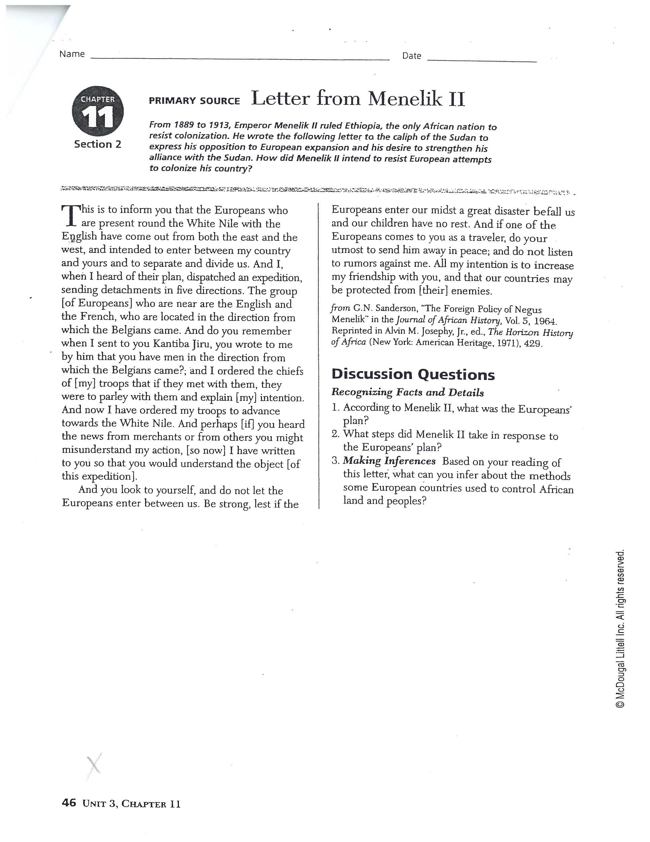

***GENOCIDE ASSIGNMENT***

***Unit 1:***

*Tutorial:* Imperialism in Africa, the Middle East, and Latin America

Look up online the official, legal definition of genocide as determined by the Genocide Convention of the United Nations Assembly. Read it carefully. Explain the definition below **in your own words**.

Do all countries in the UN abide by this definition?

What are the penalties for commission of genocide?

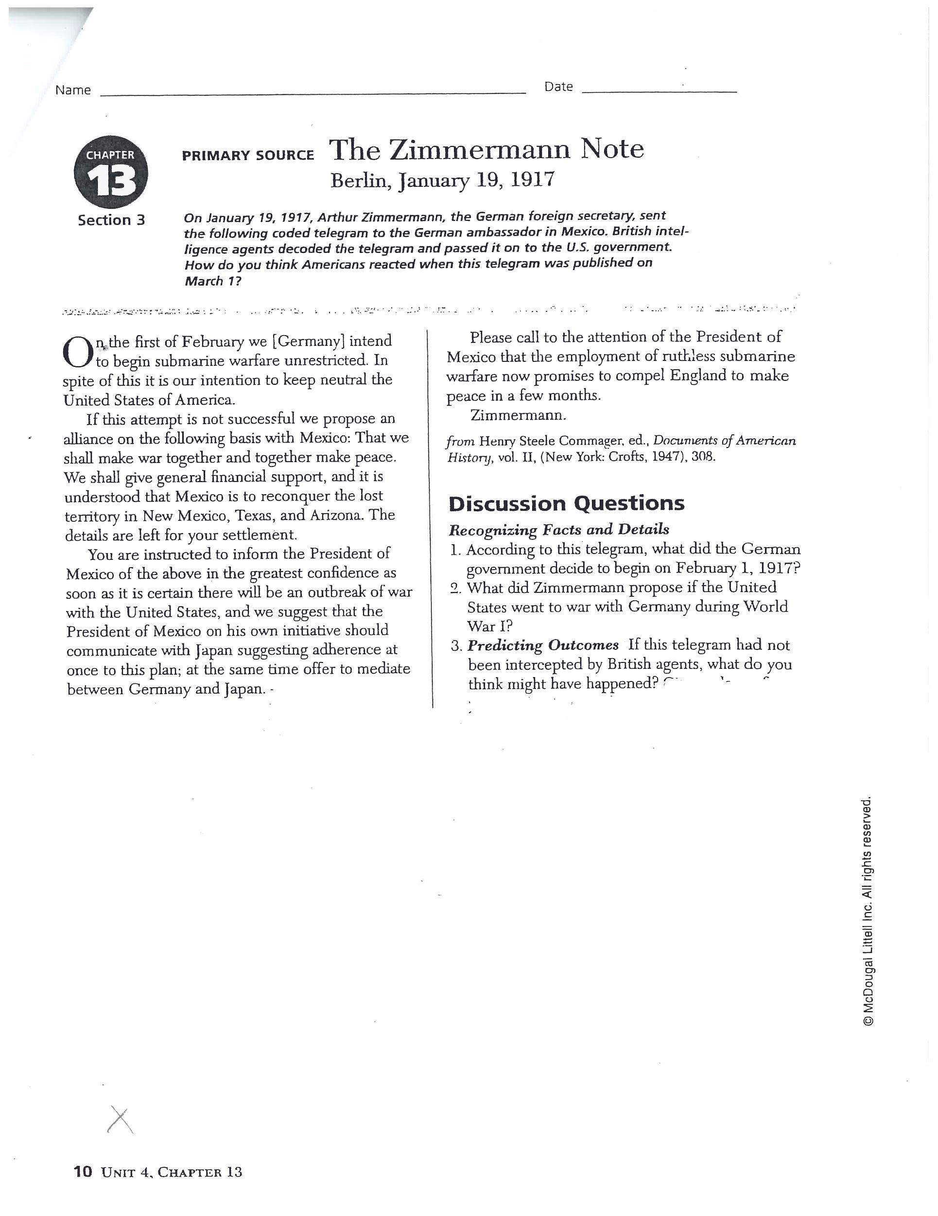

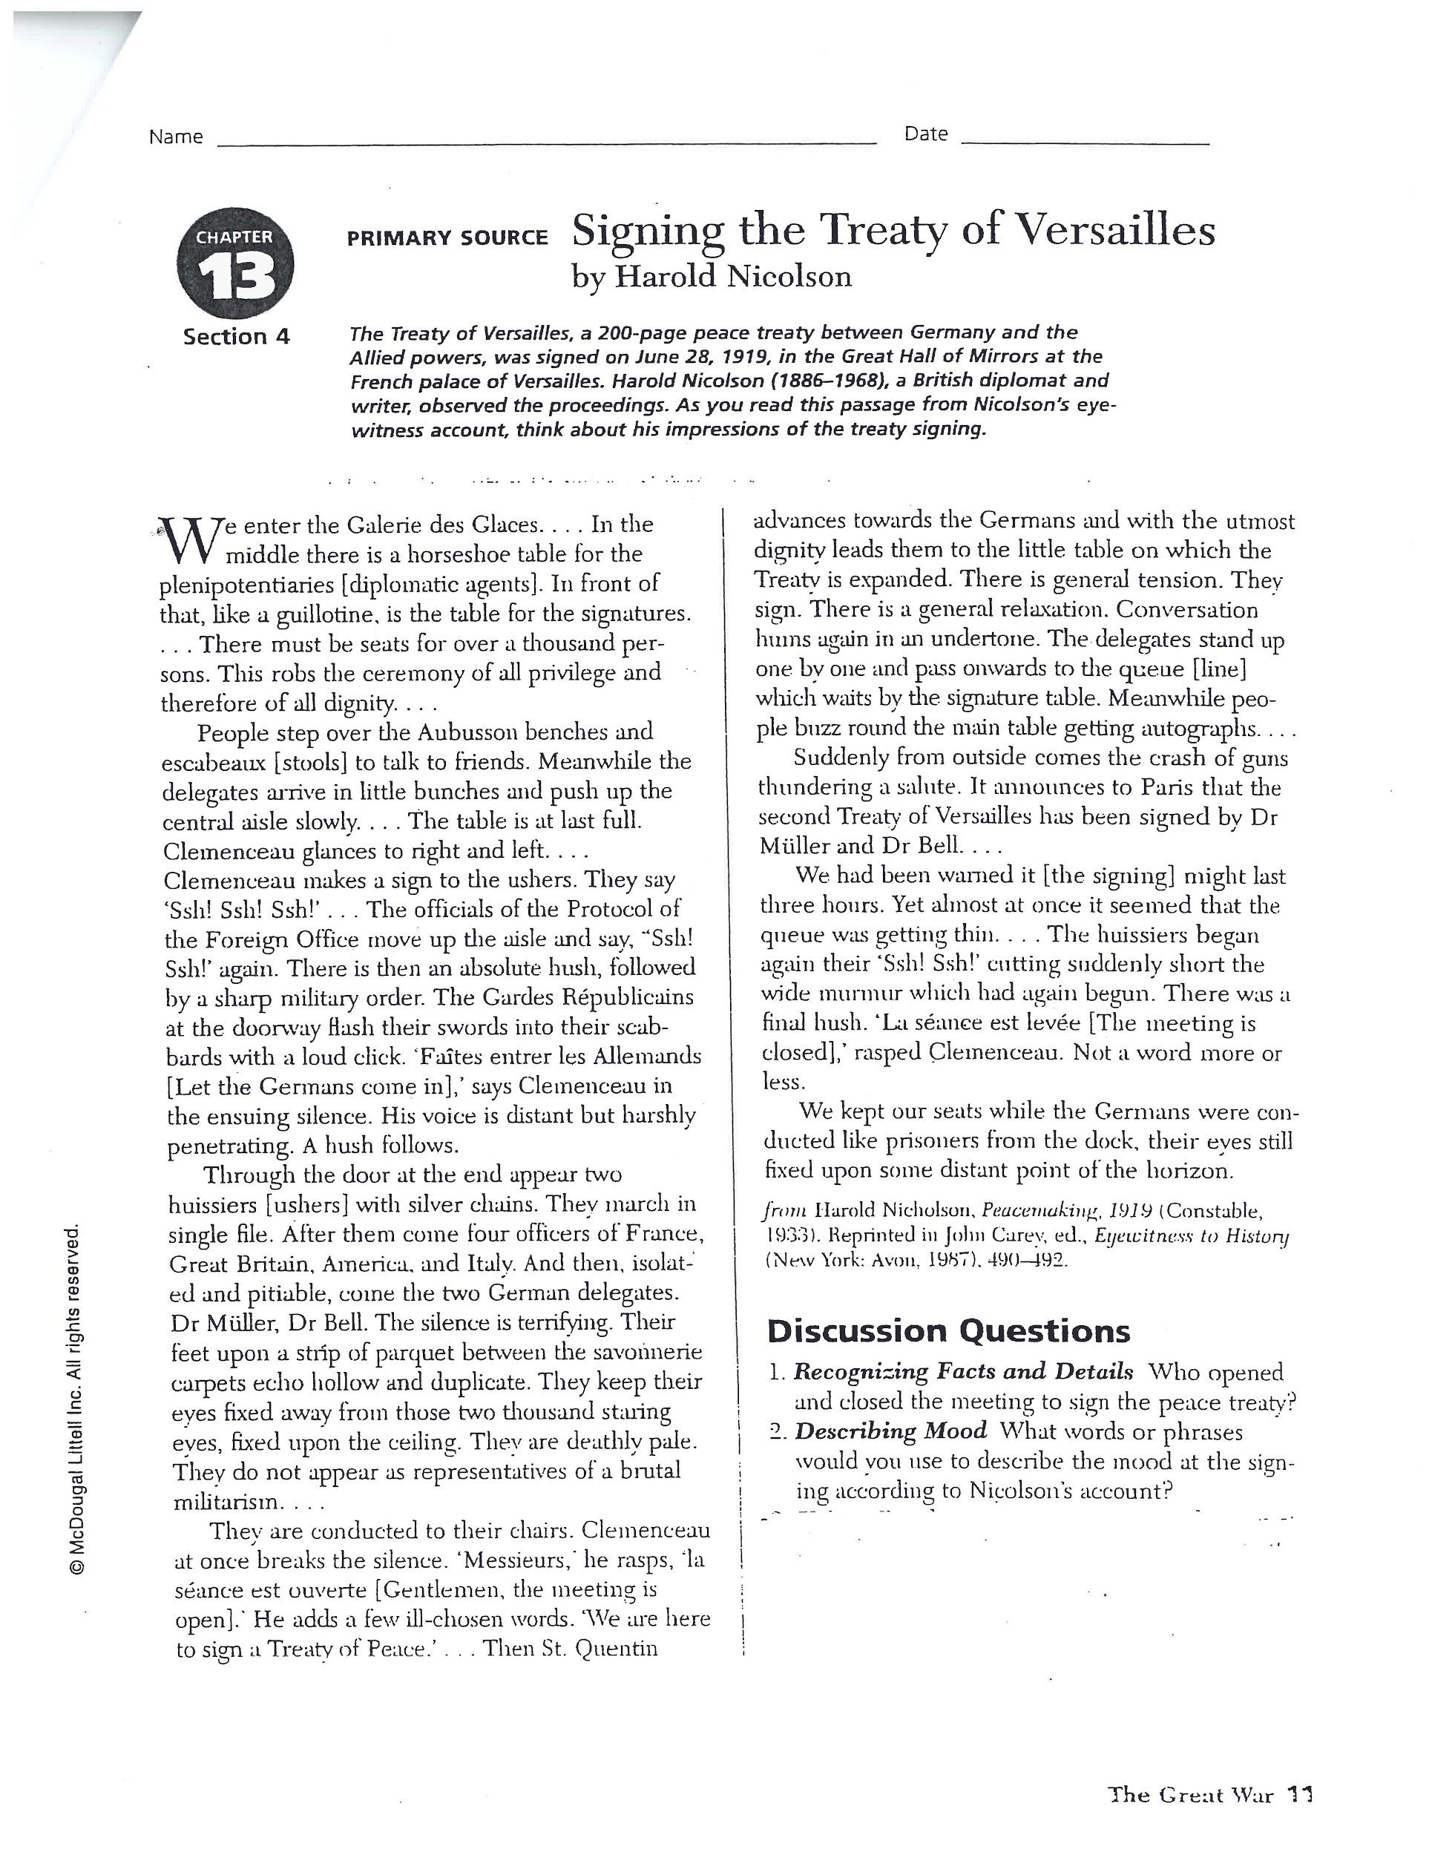

***JOHN MAYNARD KEYNES***

***Unit 1***

*Tutorial:* World War I Ends

On p.21, the historian ends her video by reminding us of John Maynard Keynes’ theme… ”We’re all in it together”.

Review the video and then answer the question below.

What was the “it” he was referring to?

What worried him about next steps after the end of World War I?

How does his theme apply to our world today?

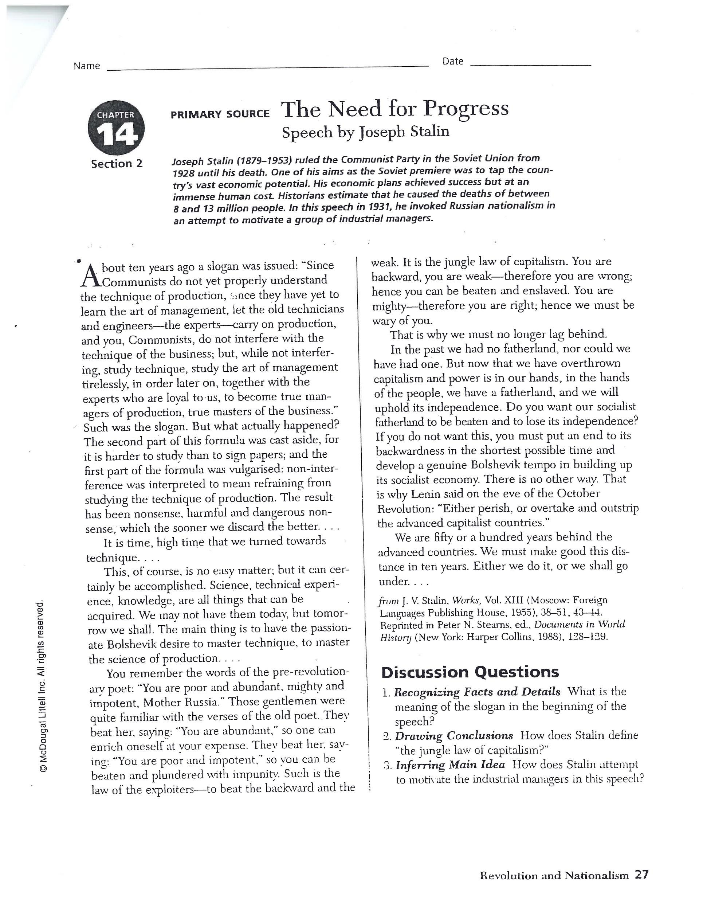

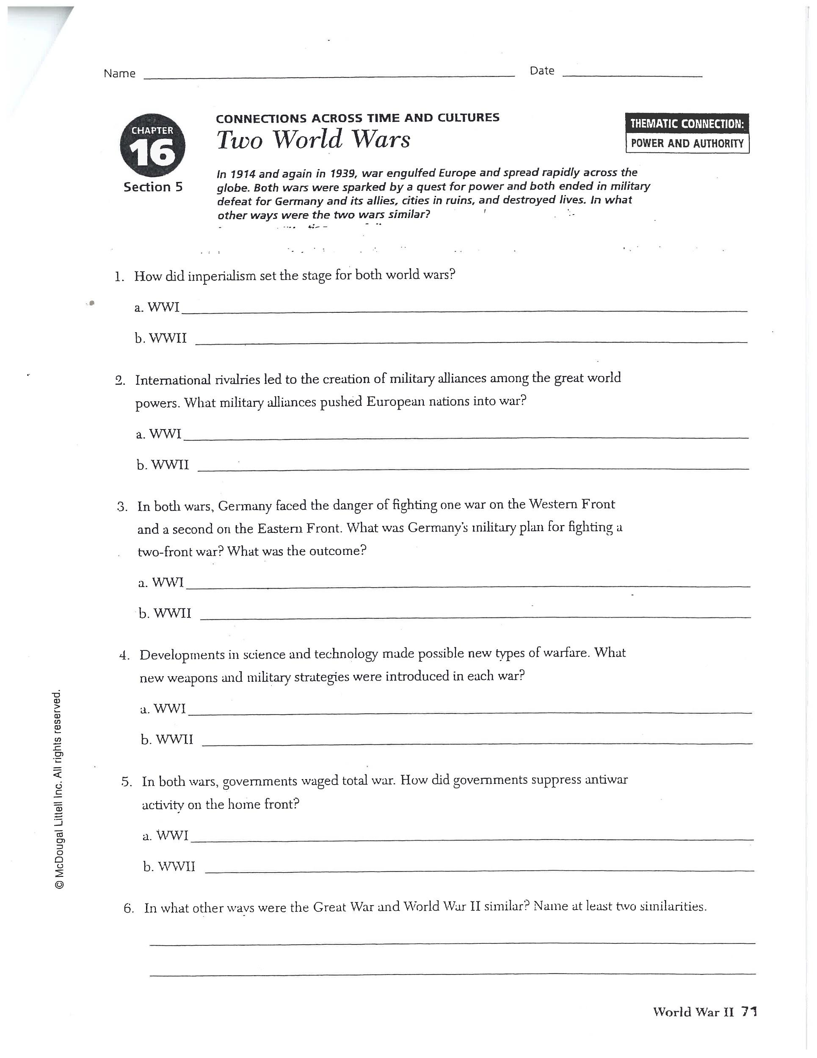

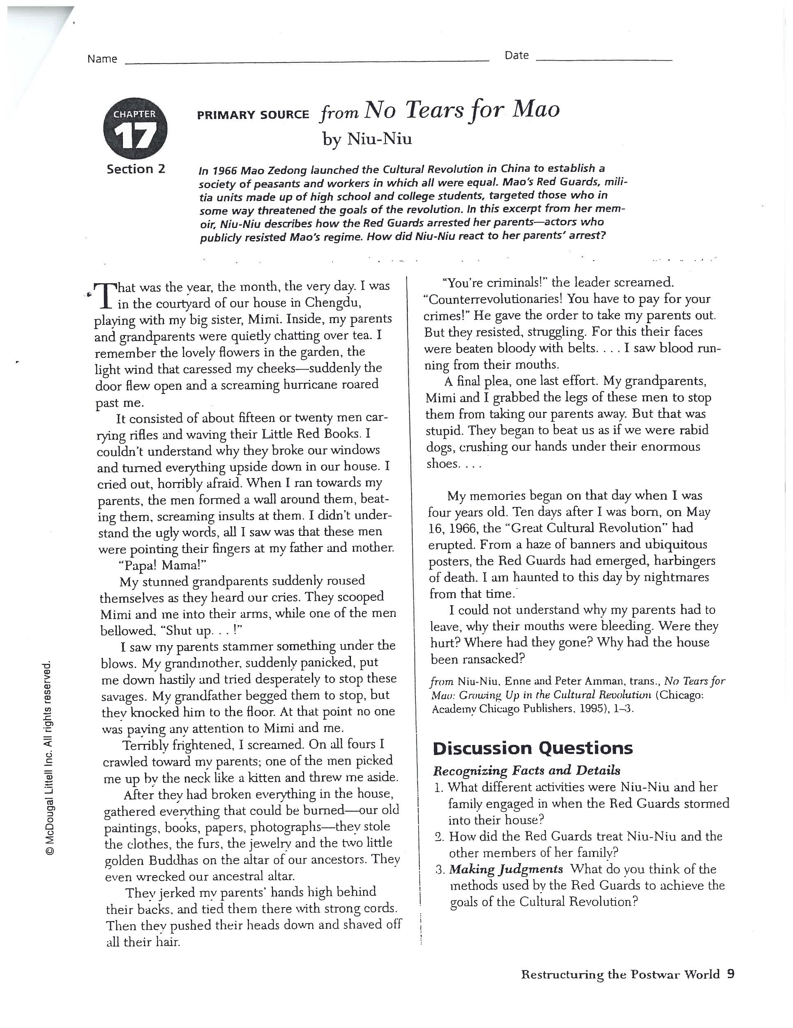

**Epilogue Questions:**

1. Describe two ways in which the revolution in electronics has changed the world:

**a).**

**b).**

**2.** Discuss three effects of air pollution on the environment:

**a)**.

**b).**

**3.** Name two factors that have contributed to famine in Africa

**a).**

**b).**

**4.** What are the IMF and the World Bank?

IMF:

World Bank:

**5.** What makes terrorism frightening to so many people?

**6.** How has the UN attempted to protect the rights of children?

**World History B**

**Record Sheet/Student Grades - Name:** ______________________________

|  |  |  |  |  |
| --- | --- | --- | --- | --- |
| ***UNIT 1:***  ***Imperialism and World War I*** | ***Date*** | ***Hrs.*** | ***Grade*** | ***Teacher Initial*** |
| **Primary Sources Tutorial** |  |  |  |  |
| **The Rush for Empire Tutorial**   * Mastery Test |  |  |  |  |
| **Imperialism in East Asia,**  **India and the Pacific Tutorial**   * Mastery Test |  |  |  |  |
| **Imperialism in Africa, the Middle East, and Latin America Tutorial**   * Worksheet “Primary Source: Letter from Menelik II” * Worksheet “Genocide Assignment” * Mastery Test |  |  |  |  |
| **The Great War Tutorial**   * Page 23 * Worksheet “Zimmerman Note” * Mastery Test |  |  |  |  |
| **World War I Ends Tutorial**   * Worksheet “Treaty of Versailles Primary Source” * ”John Maynard Keynes assignment” * Duke Ellington video * Fats Waller video * Mastery Test |  |  |  |  |

|  |  |  |  |  |
| --- | --- | --- | --- | --- |
| ***UNIT 2: World War II*** | ***Date*** | ***Hrs.*** | ***Grade*** | ***Teacher Initial*** |
| **Between the Wars Tutorial**   * Jesse Owens Video * Worksheet   “Need for Progress (Stalin)”   * Page 51 * Mastery Test. |  |  |  |  |
| **War Breaks Out Tutorial**   * Page 6t * Kristallnacht Video * Page 14, Paragraph 2 questions * Page 44, questions about immigrants * Mastery Test. |  |  |  |  |
| **The War in Europe and the Pacific Tutorial**   * FDR video * Rosie the Riveter video * Mastery Test. |  |  |  |  |
| **The Holocaust and Other Atrocities Tutorial**   * Page 6, Wiesel quote * Page 24, Niemoller poem. * Elie Wiesel Video * P47, Parts A, B, and C. * Mastery Test. |  |  |  |  |
| **The Allies Win Tutorial**   * Page 32 * Page 52, Question 2,   Parts A and B and Question 3.   * Mastery Test. |  |  |  |  |
| **Unit 2 Activity:**  *Navajo Code Talkers link* |  |  |  |  |
| ***Extra Credit:***  *Worksheet “Two world Wars”* |  |  |  |  |

|  |  |  |  |  |
| --- | --- | --- | --- | --- |
| ***UNIT 3:***  ***Communism & The Cold War*** | ***Date*** | ***Hrs.*** | ***Grade*** | ***Teacher Initial*** |
| **The Rise of Communist Governments Tutorial**   * Mastery Test. |  |  |  |  |
| **The Cold War Heats Up Tutorial**   * Page 15, A,B,C; * Mastery Test. |  |  |  |  |
| **The Cold War Spreads Tutorial**   * Mastery Test. |  |  |  |  |
| **The Cold War Ends Tutorial**   * Van Cliburn video * Mastery Test. |  |  |  |  |

|  |  |  |  |  |
| --- | --- | --- | --- | --- |
| **Unit 4: *A Changing Globe*** | ***Date*** | ***Hrs*** | ***Grade*** | ***Teacher Initial*** |
| **The End of Empires in Asia Tutorial**   * Mastery Test. |  |  |  |  |
| **Modern China Tutorial**   * Worksheet “No Tears for Mao” * Page 37, A and B * Mastery Test |  |  |  |  |
| **Decolonization in Africa Tutorial:**   * Desmond Tutu video * Nelson Mandela video * Page 39, A and B * Mastery Test |  |  |  |  |
| **Revolution and Reaction in the Americas Tutorial:**   * Page 41 * “Evita” video * Mastery Test |  |  |  |  |
| **Nationalism in the Middle East Tutorial**   * Mastery Test |  |  |  |  |

|  |  |  |  |  |
| --- | --- | --- | --- | --- |
| ***Unit 5:***  ***The Contemporary World*** | ***Date*** | ***Hrs.*** | ***Grade*** | ***Teacher Initial*** |
| **Economic Globalization Tutorial**   * Mastery Test. |  |  |  |  |
| **A Global Society Tutorial**   * Page 37 * Mastery Test |  |  |  |  |
| **Terrorism Tutorial**   * Page 6 Teacher 9/11 Interview * Mastery Test |  |  |  |  |
| **Science and Technology in a Changing World Tutorial**   * Mastery Test. * Worksheet “Epilogue Questions” |  |  |  |  |
| **Unit 5 Activity***:* Page 5 |  |  |  |  |

|  |  |  |  |  |
| --- | --- | --- | --- | --- |
| **FINAL** | ***Date*** | ***Hrs.*** | ***Grade*** | ***Teacher Initial*** |
|  |  |  |  |  |